Josie DeMarco
March 3, 1931 – March 17, 2013

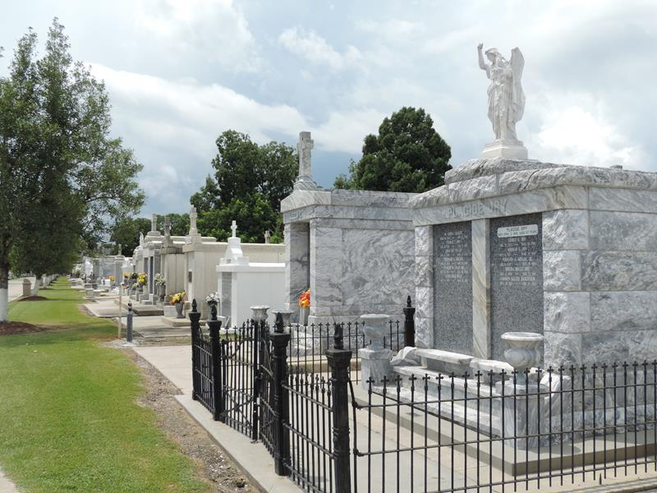

DeMARCO Josie, "Nan," DeMarco, age 82, entered into her eternal rest on Sunday, March 17, 2013, at 1:13AM.
She was a lifelong resident of Reserve, LA, and was preceded in death by her parents Anthony and Virginia DiPasquale of Italy; her sisters Stella Cortez, Mamie Cashio, and Rosalie Zappula; and her brothers Russell DeMarco and Anthony DeMarco, Jr.
She is survived by her brothers Sal S. DeMarco of Bartlesville, OK; and Joseph DeMarco of Sacramento, CA. She was a second mother to her nephews and nieces: Nicholas Cashio, Jr., (Cathy), Darryl Cashio, Corliss Klibert, and Mary Punch (Michael). She is lovingly missed and remembered by her numerous nieces and nephews, great-nieces and great-nephews, great-great nieces and great-great nephews, as well as many family and friends whom she loved dearly.
Josie retired from the Reserve Telephone Company after 23 years of employment and later became a devoted caregiver to the late Mrs. Richard Becnel, the late Mr. & Mrs. Albert T. Becnel, and the late Mrs. Beatrice Maurin.
She was a proud member of the St. Peter's Church Choir in Reserve and the Ladies' Altar Society and kept herself busy through various volunteer activities and through her unending care of and devotion to her family and friends. No one was a stranger to Josie; she was truly a living reminder of God's love. Our angel on earth is now watching over all of us from heaven. She will be forever loved and missed.
Relatives and friends are invited to attend services. Visitation at St. Peter Catholic Church, Reserve, LA, on Thurs, March 21, 2013, from 9:30AM to 11:30AM, followed by Mass at 11:30AM. Burial in St. Peter Cemetery, Reserve. Arrangements by Millet-Guidry Funeral Home, LaPlace, LA.

The Times-Picayune, New Orleans, Louisiana
March 19-20, 2013

