Russell Ross Demarco

June 26, 1926 – April 30, 2005

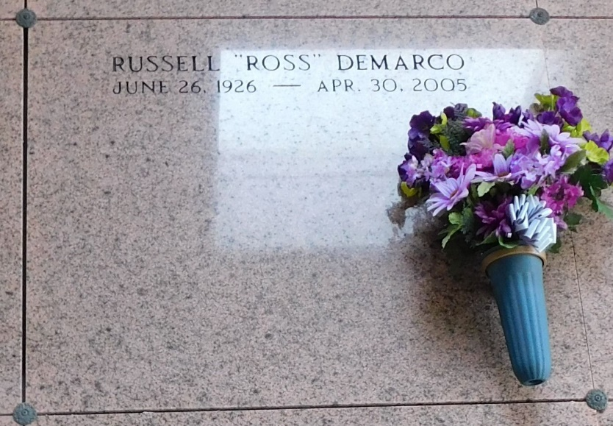

Photo by Mary Agnes Hammett

Russell 'Ross' Demarco On Saturday, April 30, 2005 At 9:00 A.M.

Beloved Son Of The Late Anthony And Virginia Depasquale Demarco, Sr. Brother Of Rosalie D. Zappula Of San Jose, Ca, Josie Demarco Of Reserve, La, Salvador Demarco Of Bartlesville, Ok And Joseph Demarco Of Sacramento, Ca. Preceded In Death By Sisters: Stella Cortez And Mamie Cashio; And Brother, Anthony Demarco, Jr. Also Survived By A Host Of Other Relatives And Friends. Age 78 Years. A Native And Lifelong Resident Of Reserve, La.

Relatives And Friends Of The Family Are Invited To Attend Services. Visitation At St. Peter Catholic Church, Reserve, La On Tuesday, May 3, 2005 From 9:00 A.M. Until 11:00 A.M. Followed By A Mass Of Christian Burial At 11:00 A.M. Burial Will Be In Church Cemetery. In Lieu Of Flowers, Masses Preferred. Millet-Guirdy Funeral Home, Laplace, La In Charge Of Arrangements.

The Times-Picayune, New Orleans, Louisiana

May 1, 2005