Corinne (Vicknair) Delaneuville

February 2, 1876 – February 1, 1947

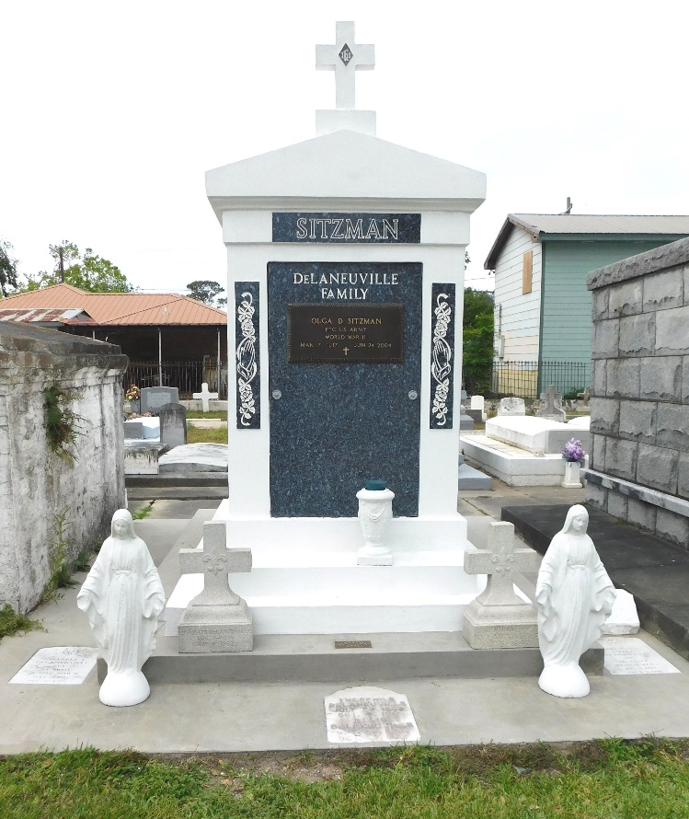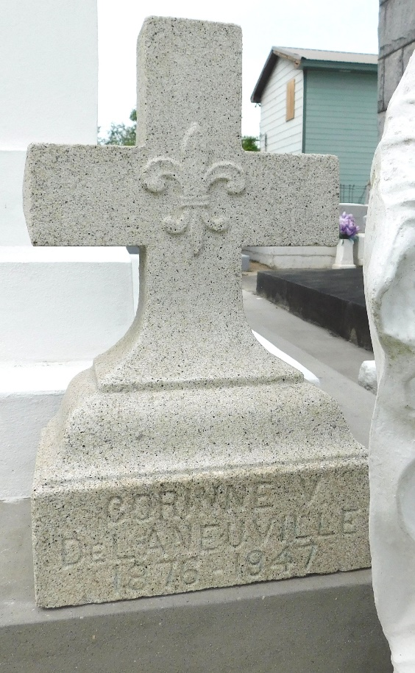

Photos by Mary Agnes Hammett

Corinne Vicknair Delaneuville, a native and resident of Reserve, Louisiana, died at Charity Hospital, New Orleans, on Saturday 1 Feb 1947 at 1:45 pm at age 70 years.

She was the wife of the late Emile De Laneuville and the mother of Nemour, Bharles, Theodora and Olga De Laneuville, Mrs. Lydia Schwartz, Mrs. Denise De Laneuville, Mrs. Georgette Howard, Mrs. Lucille Schexnayder, Mrs. Jeanette Jacob, Mrs. Virginia Duhe, Mrs. Ida Wonack and the late Ellis, Theophile and Emile De Laneuville II. Also survived by 26 grandchildren and four great-grandchildren.

Services were Monday 3 Feb 1947 at St Peter Catholic Church, Reserve, with interment in St Peter Cemetery, Reserve.

The Times-Picayune, New Orleans, Louisiana

3 Feb 1947