Elaine (Maurin) Delaneuville
August 14, 1915 – April 8, 2017

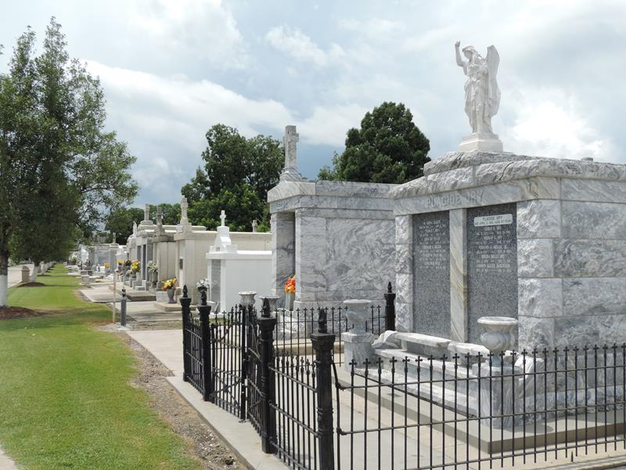

Elaine Maurin Delaneuville, age 101, passed away on Saturday, April 8, 2017 in Reserve, Louisiana. She was a native and lifelong resident of Reserve.
Beloved wife of the late Dewey A. Delaneuville. Daughter of the late Louis J. Maurin, Sr. and Emma LeBrun Maurin. Sister of the late Marjorie Maurin McTopy (late John McTopy), late Louis J. Maurin, Jr. (late Ruth Schexnaydre), Marie Therese Maurin Montz (late Armand M. Montz, Jr.), late Gloria Mae Maurin Oubre (late Richard P. Oubre), late Joseph LeBrun Maurin (Marilyn Torres) and the late Jo-Anne Maurin Montz (late Warren “Smokey” Montz). Survived by many dearly beloved nieces and nephews.
Elaine worked in her father’s theater business (Maurin’s Theaters) selling tickets and performing many other duties including selling War Bonds during World War II. She was one of the sweetest and most caring individuals one could have had the pleasure of knowing. She will be dearly missed by all. Elaine’s family would like to thank all of her caregivers and also extends thanks to the staff of Hospice Compassus.
Relatives and friends are invited to attend the Mass of Christian Burial at St. Peter’s Catholic Church, 1550 Hwy 44, Reserve on Wednesday, April 12, 2017 at Noon. Visitation will begin in church at 10:00 A.M. Interment in St. Peter’s Church cemetery.
Millet-Guidry Funeral Home, LaPlace, Louisiana

