Gene R. Delaneuville

August 29, 1935 – September 18, 1910

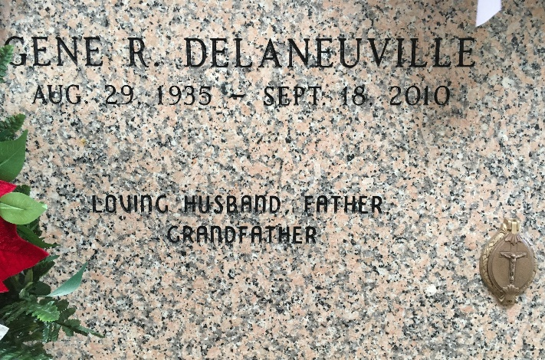

Photo by Team T-Lo

 Gene R. Delaneuville passed away on Saturday September 18, 2010. Beloved husband of Gwen Klibert Delaneuville. Father of Lori Poirrier and husband Aaron, Lisa Bergeron and husband David and Scott Delaneuville and wife Angel. Grandfather of Ashley Titus, John Paul and Matthew Poirrier, Brett Bergeron, Ryan and Katie Delaneuville. Great-grandfather of Matelyn and Ory Titus. Son of the late Pelham P. and Mildred Delaneuville. Brother of Pelham J. Delaneuville and wife Laverne. Special thanks to River Region Hospice and Eagan Health Care. Age 75. A native of Reserve and a resident of LaPlace. Relatives and friends, also employees of Marathon Oil Refinery Garyville and Jacobs Engineering of Baton Rouge are invited to attend services. Visitation at St. Joan of Arc Catholic Church, 529 W. 5th St., LaPlace, La., on Tuesday, September 21, 2010 from 9:00 AM to 11:00 am. Followed by Mass at 11:00 AM. Burial in St. Peter Cemetery, Reserve. Arrangements by Millet-Guidry Funeral Home, LaPlace, La.

Times-Picayune, New Orleans, Louisiana

September 19-20, 2010