Jed G. Delaneuville
January 22, 1962 – June 21, 1989

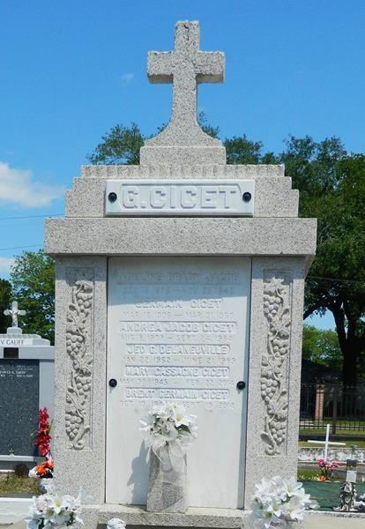

A 27-year-old Reserve man who had just been married was killed in a traffic accident in LaPlace late Tuesday while riding in a truck with his bride of two hours.
Jed G. Delaneuville, 27, 117 W. First St., was driving his pickup truck at a high rate of speed about 11:30 p.m. on Louisiana 44 when the vehicle went out of control and hit a building and a telephone pole, State Police said. Delaneuville was pronounced dead a short time later at River Parishes Hospital.
His wife, Sheila, 19, was treated at the same hospital for minor injuries and released, said the St. John the Baptist Sheriff's Office. The couple was married Tuesday at 9:30 p.m., said Lt. Rick Highlander, of the Sheriff's Office.
The truck hit a fruit stand in front of Bailey's Butcher Shop near the junction of Louisiana 628, just off of Main Street (Louisiana 51), Highlander said.

Times-Picayune, The (New Orleans, LA)
Thursday, June 22, 1989

