Marie (Battard) Delaneuville

October 3, 1913 – August 20, 2003

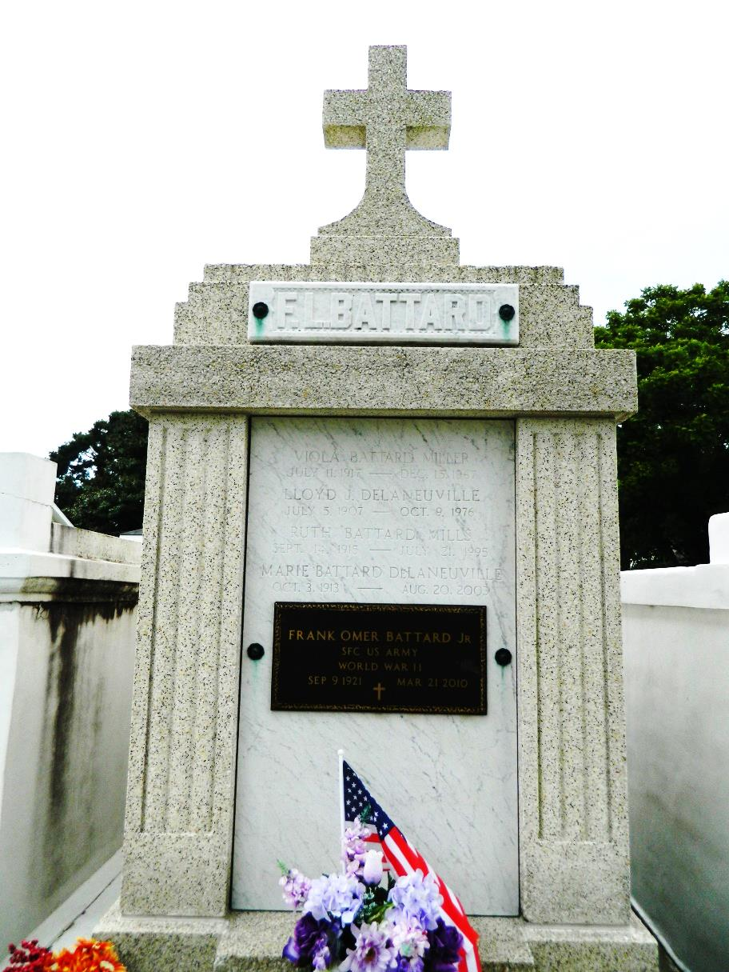 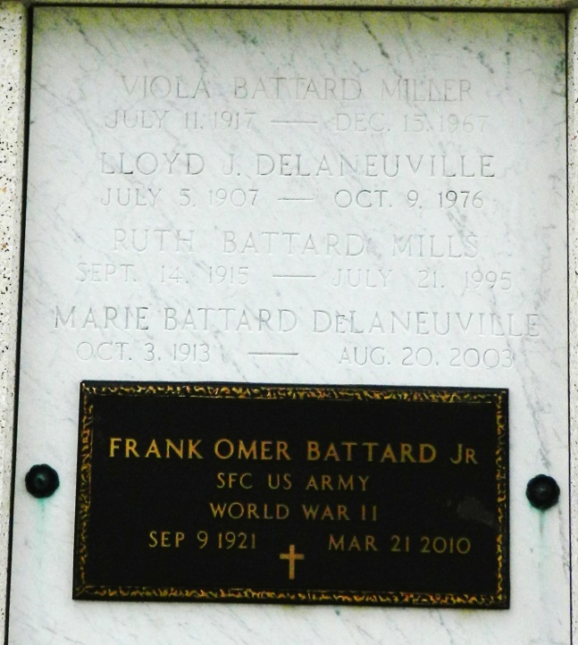

RESERVE - Marie Battard DeLaneuville, 89, a native and resident of Reserve, died Aug. 20. She was the wife of the late Lloyd DeLaneuville, and mother of Brenda Keating, Huey, Arthur, Wayne "Do-Do" and Ronnie DeLaneuville.   
 She was also the daughter of the late Frank and Lea Battard, and sister of Therese Picton, Blanche Vicknair and Frank Battard, and the late Ruth Mills, Viola Miller and Anthony Battard. She is also survived by nine grandchildren and six great-grandchildren.   
 Services were Aug. 22 at St. Peter Catholic Church, Reserve, with interment at the church cemetery.

L'Observateur (La Place, LA) — Monday, August 25, 2003

Contributed by Jane Edson