Raymond Jerry Delaneuville
February 1950 – May 16, 2023

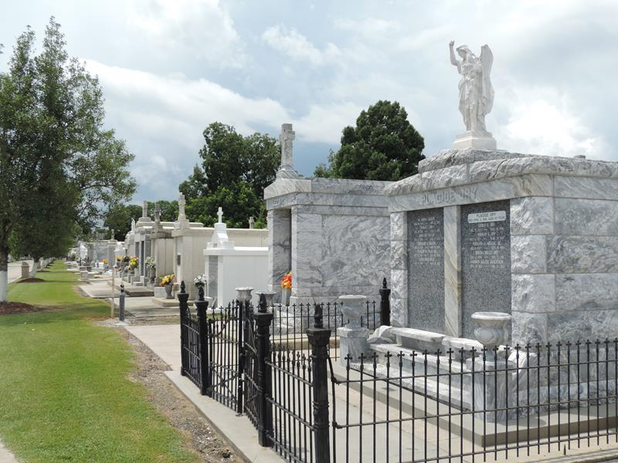

Raymond Jerry “Brother” Delaneuville, born in February 1950, passed away on May 16, 2023, at the age of 73. He was laid to rest at Saint Peter Catholic Church Cemetery in Reserve, St. John the Baptist Parish, Louisiana.
Raymond Jerry “Brother” Delaneuville lived a full and impactful life. Born in February 1950, he was a beloved member of his community in Reserve, Louisiana. Known for his warm personality and dedication to his family and friends, he left a lasting impression on everyone who knew him.
Throughout his life, Raymond was deeply involved in his local community. He was an active member of Saint Peter Catholic Church, where he participated in various church activities and events. His commitment to his faith and community service was evident in everything he did.
Raymond was also known for his love of the outdoors, often spending time fishing and enjoying nature. His passion for these activities was something he shared with his family, creating many cherished memories.
Raymond Delaneuville was a cherished member of a close-knit family. He was a devoted husband, father, and grandfather, known for his deep love and commitment to his family. His family was a central part of his life, and he took great pride in their accomplishments and well-being. His children: Raymond Jr., David and Lisa. Preceded in death by his parents, Eugene & Ella Vicknair Delaneuville and siblings: Eugene Jr., Robert L., & Joan Felder.
Raymond and his wife, Linda, shared a strong bond, and together they raised their children with values of love, respect, and community. His children and grandchildren remember him as a supportive and loving figure who always had time for them, whether it was sharing stories, offering advice, or simply enjoying each other’s company.
Family gatherings were important to Raymond, and he often brought everyone together for celebrations, holidays, and special occasions. His home was a place of warmth and hospitality, where family and friends were always welcome.
Raymond’s legacy lives on through his family, who continue to honor his memory and the values he instilled in them.

Note: this obit was generated by Aritificial Intelligence

