Helen Marie (Catoire) Delhommer

November 21, 1920 – April 8, 2002

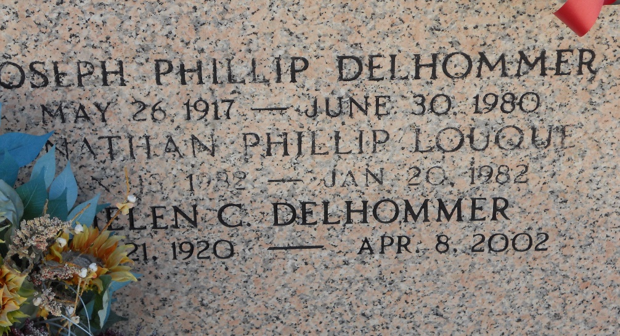

Photo by Team T-Lo

Marie Helen Catoire Delhommer on Monday, April 8, 2002, at 6:48 PM.

Beloved wife of the late Joseph Delhommer. Mother of Jo Ann Madere of LaPlace, LA , Donna Allison of Birmingham, AL, Mary Elizabeth Clement of Laranger, LA and the late Maria Louque Acosta. Daughter of the late Rene and Elvire Chapoton Catoire. Sister of Elmore Catoire of Baker, LA, Pershing Catoire of Baton Rouge, LA, Louise Oubre and Mae Kugler of LaPlace and the late Clarence, Henry and Lloyd Catoire and Lucille Keller. Also survived by 11 grandchildren, 7 great-grandchildren and 1 deceased grandson. Age 81, a native of Reserve and a resident of LaPlace for the past 42 years.

Relatives and friends of the family are invited to attend the funeral services at Millet-Guidry Funeral Home, 2806 West Airline Hwy, LaPlace, on Thursday, April 11, followed by religious services at St. Joan of Arc Catholic Church, LaPlace, at 11:00 AM. Burial in St. Peter Cemetery, Reserve. Visitation from 5 PM to 10 PM on Wednesday, and from 8 AM until services on Thursday. In lieu of flowers, please make donations to Hospice.

The Times-Picayune, New Orleans, Louisiana

Apr. 10, 2002