Joseph Octave Delhommer

March 17, 1875 – February 28, 1937

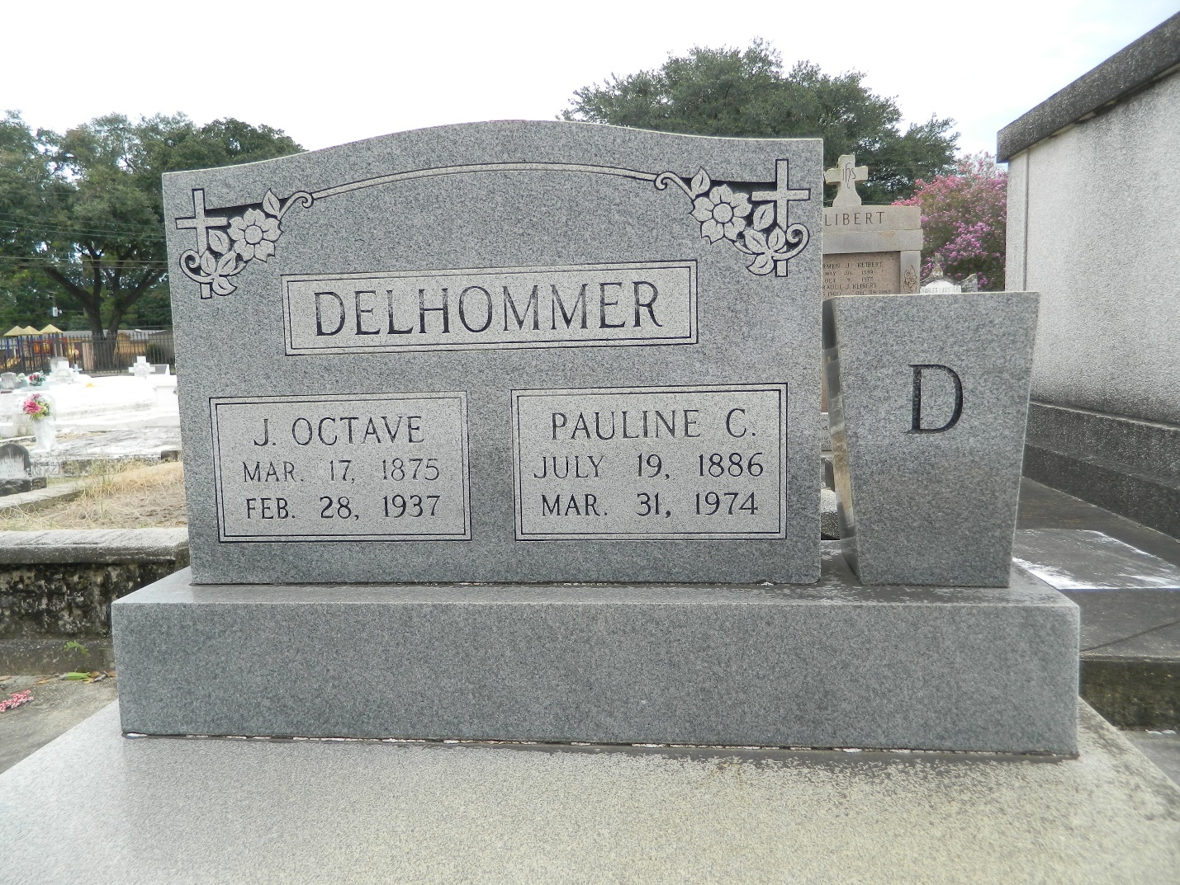

Joseph Octave Delhommer died on Sunday 28 Feb 1937 at 6 o'clock a.m.

Husband of Pauline Clement and the father of Mrs. M. L. Satterlee, Mrs. Clay Delauneville, Mrs. Horace Granier and Laura and Joseph Delhommer. Aged 62 years.

Relatives and friends of the family, also employees of General American Tank and Storage Terminal of Good Hope, LA, are invited to attend the funeral which will take place Monday 1 Mar 1937 from the Jules Millet funeral home, Reserve, LA. Religious services at St Peter's Church, Reserve, with interment in St Peter Cemetery.

The Times-Picayune, New Orleans, Louisiana

March 1, 1938, p. 2