John Joseph Demarcay

May 13, 1892 – February 22, 1968

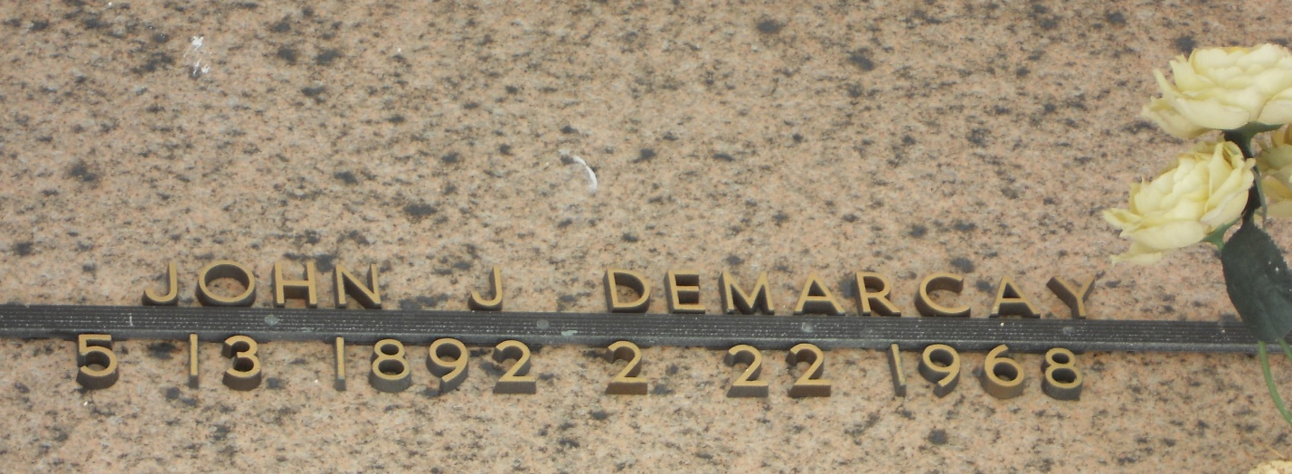

Photo by Team T-Lo

John J Demarcy (sic), age 75 years, a native and resident of Reserve, Louisiana, died Thursday 22 Feb 1968 at 1:00 pm.

He was the son of the late Damase Demarcy and Clara Duhe and the brother of the late Mrs. Blanche Demarcy Weber.

Services were Friday 23 Feb 1968 at St Peter Church, Reserve, with interment in St Peter Cemetery, Reserve.

The Times-Picayune, New Orleans, Louisiana

23 Feb 1968