Montrell Ramon Dennis

August 17, 1971 – February 17, 2022

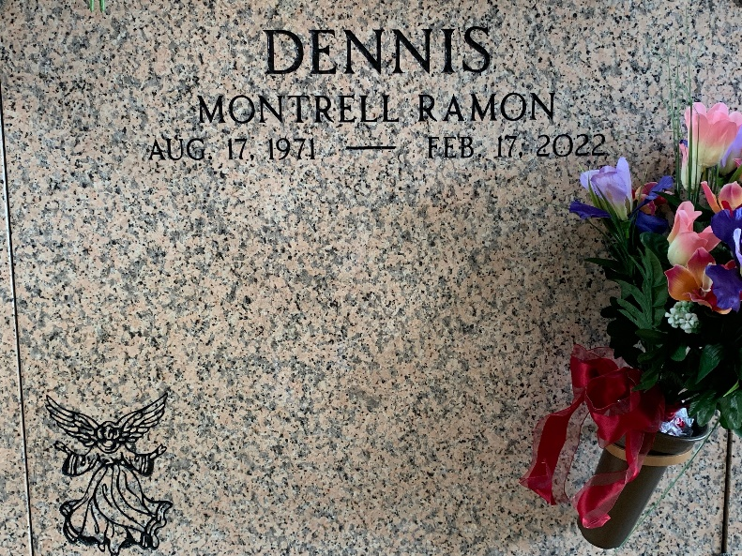

Photo by Team T-Lo

[Montrell Ramon Dennis, born on August 17, 1971, passed away on February 17, 2022, in Humble, Texas](https://www.tributearchive.com/obituaries/24057204/montrell-ramon-dennis). [He was laid to rest in Reserve, Louisiana](https://www.findagrave.com/memorial/236895276/montrell-ramon-dennis). A service was held on February 28, 2022, at St. [Mary Magdalene Catholic Church in Humble, Texas](https://www.tributearchive.com/obituaries/24057204/montrell-ramon-dennis).

He was the beloved son of Mary Dennis and the late Robert Dennis. He is also survived by his siblings, including his sister, Lisa Dennis, and his brother, Robert Dennis Jr. Montrell married Angela Dennis. He was a devoted father to his children, Jasmine Dennis and Montrell Dennis Jr.

He worked as a high school teacher, where he was known for his commitment to his students and his passion for teaching. He specialized in teaching mathematics and science at the high school level. He was highly regarded for his ability to make complex subjects accessible and engaging for his students.

Obituary generated by Artificial Intelligence (Copilot)