Susan Joan (Torres) Deroche

May 6, 1959 – August 29, 2015

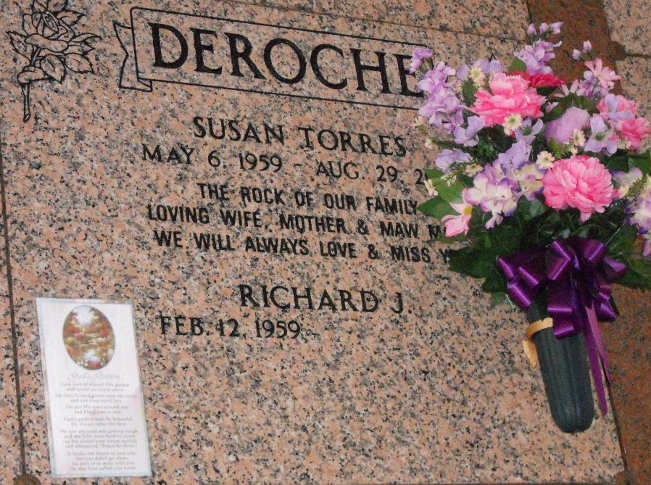

Photo by Team T-Lo

Susan Torres Deroche, was born on May 6, 1959 and passed away at her home on Aug. 29, 2015. She was a native and a resident of Garyville.  
 Survived by Husband: Richard “Boo Boo” Deroche; Sons: Derek Deroche and wife, Katie; Timothy and Brett Deroche; Mother: Nellwyn King Torres; Brothers: Warren J. Torres Jr. and Brent Torres; Sisters: Connie Babin, Paula “Reesie” LeBlanc, Lisa Faucheaux; Grandchildren: Zoey, Summer, Destiney and Hope Deroche. Sisters-in-law: Keither Montz, Karen Roddy and husband Donald, Gayle Miller and husband Harold, Kay Veron and husband Mac, Nancy Cashio and husband Curtis; Brothers-in-law: Jerry Deroche and wife Margaret and Kirby Deroche and wife Sharon  
 Preceded in death by Father: Warren J. Torres Sr.; Mother-in-law: Elise Bourgeois Deroche; Father-in-law: Richard Deroche Jr.; Brother-in-law Wallace Montz  
 Visitation will be Wednesday, Sept. 2, 2015 at St. Hubert Catholic Church,  
Garyville, LA from 9 until 10:45 a.m. followed by Mass of Christian Burial at 11 a.m. Interment in St. Peter’s Cemetery, Reserve, LA. Rose Lynn Funeral Services in Lutcher is in charge of the arrangements.  
  
Published in TheNewOrleansAdvocate.com from Aug. 30 to Sept. 2, 2015  
Published in TheAdvocate.com from August 30 to September 2, 2015