Eva (Roussel) Deslatte

April 28, 1903 – April 2, 1986

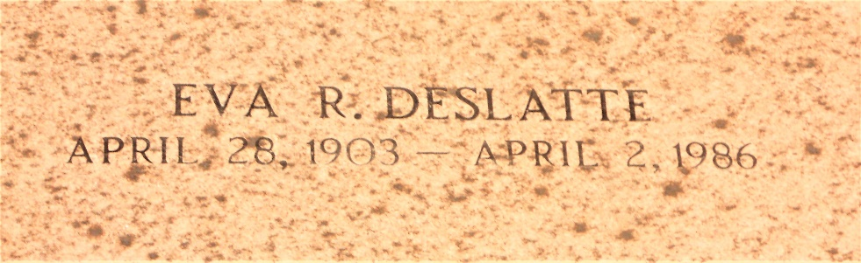

Photo by Team T-Lo

Died 1:30 p.m. Wednesday, April 2, 1986, at River Parishes Medical Center, LaPlace. She was 82, a native of Esther and resident of Garyville for the last 60 years.

Visiting at Millet Funeral Home, Reserve, 5 to 11 p.m. Thursday, and 8 to 10:30 a.m. Friday. Religious services at St. Hubert Catholic Church, Garyville, 11 a.m. Friday. Burial in St. Peter Catholic Cemetery, Reserve.

Survived by husband, Homer J. Deslatte; three daughters, Mrs. Rowanna Hymel, Mrs. Bevelyn "A.J." Landry, and Mrs. Audrey Stout; a sister, Mrs. Inez Petit; 16 grandchildren; and 33 great-grandchildren.

Preceded in death by mother and father, Pierre Roussel and Evelyn Bourgeois Roussel; six brothers, Xavier, Olida, Collins, Ewell, Elliot Sr., and Robley; and two sisters, Heloine Roussel, and Mrs. Melba Deslatte.

Unknown source