Homer Joseph Deslatte

July 29, 1904 – March 7, 1997

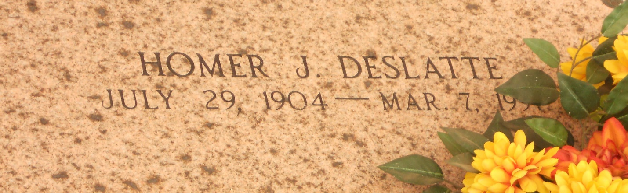

Photo by Team T-Lo

A retired St. John Parish deputy sheriff with 27 years of service and resident of Garyville for 76 years, he died Friday, March 7, 1997. He was 92 and a native of French Settlement.

Visiting at Millet-Guidry Funeral Home, 2806 W. Airline Highway, Reserve, 6 p.m. to 10 p.m. Sunday, and after 8 a.m. Monday. Religious services at St. Hubert Catholic Church, Garyville, at 11 a.m. Monday. Interment in St. Peter Cemetery, Reserve.

Survived by daughters, Rowanna Hymel, Bevelyn Landry and Audrey Stout; 16 grandchildren, 36 great-grandchildren and three great-great-grandchildren.

Preceded in death by wife, Eva Roussel Deslatte; parents, Florient and Philomene Brignac Deslatte; six brothers, Lovance, Vitalisse, Maurice, Moise, Frank and Adlar; and three sisters, Aspazie, Zeolide and Elmire.

Unknown source