Rosemary (Ruiz) Deslatte

July 30, 1930 – March 21, 2011

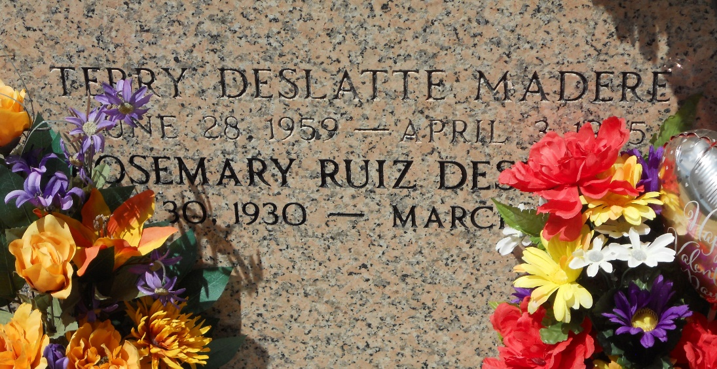

Photo by Team T-Lo

Rosemary Ruiz Deslatte passed away Monday, March 21, 2011. She was the wife of the late Clifton Deslatte, beloved mother of Mickey and Rickey Deslatte and the late Terry Madere, grandmother of Brandi Madere, Candace and Dustin Deslatte, great-grandmother of Kallie Deslatte, daughter of the late Elmo and Lavinia Ruiz, and sister of Junior Ruiz, Fay Richard and the late Clarence Ruiz. She was 80, a native of Reserve and a resident of St. Amant.

Relatives and friends also American Legion Auxiliary, VFW and St. John the Baptist Parish employees are invited to attend services. Visitation at Millet-Guidry Funeral Home, 2806 W. Airline Highway, LaPlace, on Wednesday, March 23, from 5 p.m. to 9 p.m. and Thursday from 8 a.m. to 9:45 a.m. Mass at St. Peter Catholic Church, Reserve, on Thursday at 10 a.m. Burial in St. Peter Cemetery. Special thanks to St. Elizabeth, St. James, Our Lady of the Lake and Promise hospitals.

Unknown source