Ulysses E. Deslatte
October 31, 1885 – March 8, 1966

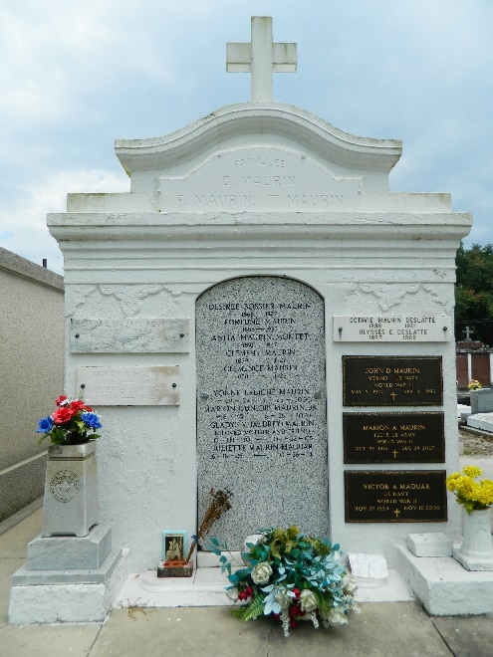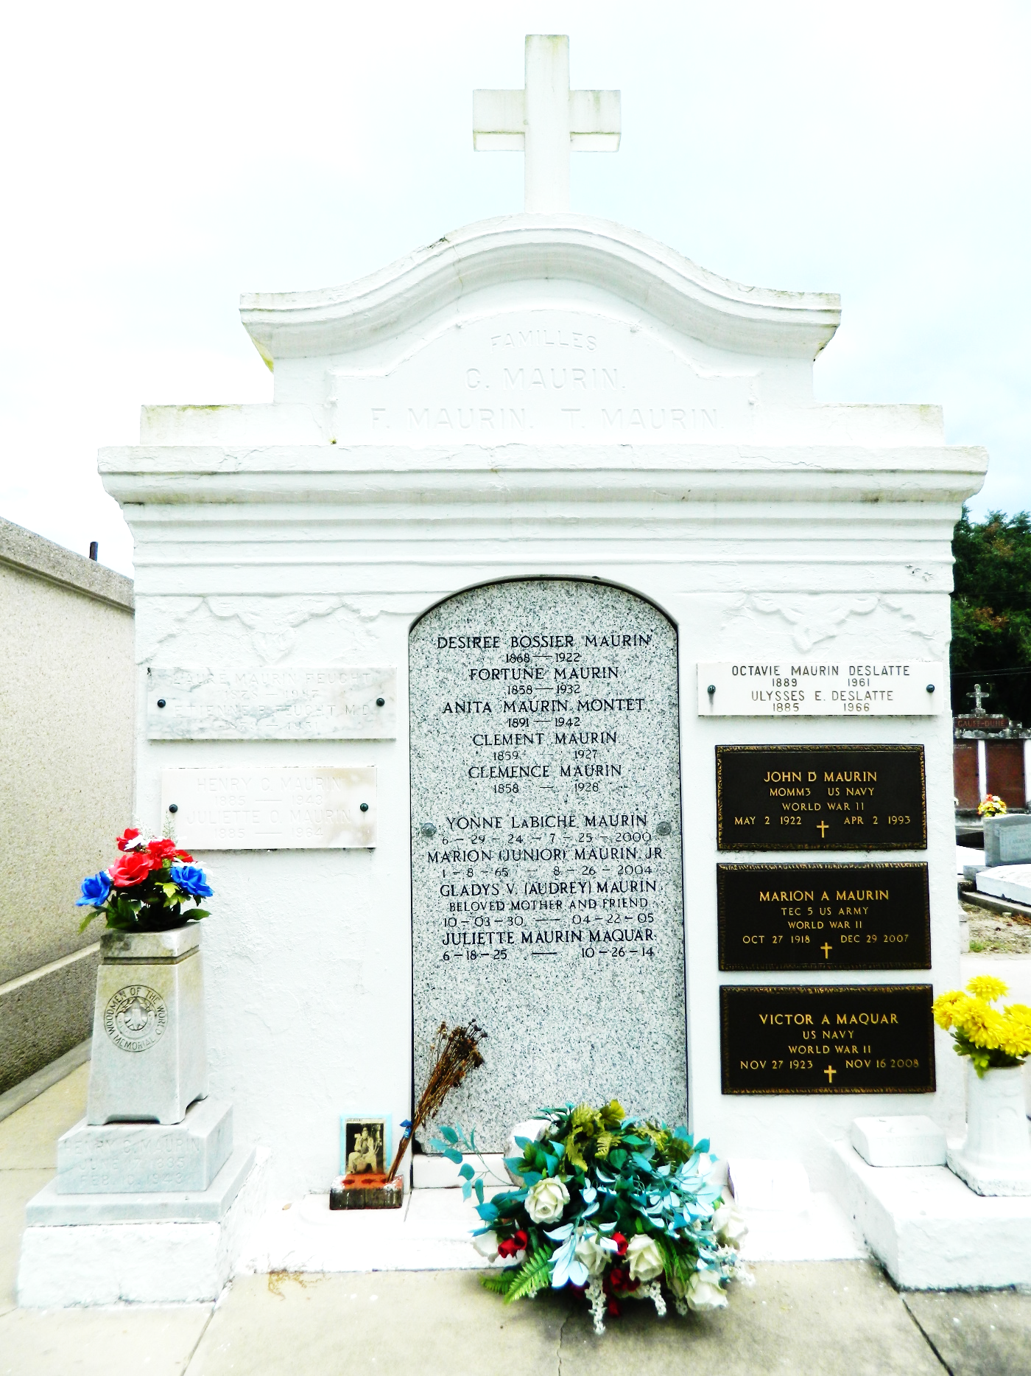

Ulysses E Deslatte died Wednesday 9 Mar 1966 at 10:25 pm.
He was the husband of the late Octavie Maurin and the son of the late Elizabeth Schexnayder and Lezin Deslatte. He was the brother of Oscar Deslatte and the late Agricole, Frank, Clifton and Jessie Deslatte.
Services were Friday 11 Mar 1966 at Mater Dolorosa Church, New Orleans, with interment in St Peter Cemetery, Reserve, Louisiana.
The Times-Picayune, New Orleans, Louisiana
11 Mar 1966

