Jules Desroches

January 8, 1838 – August 20, 1922

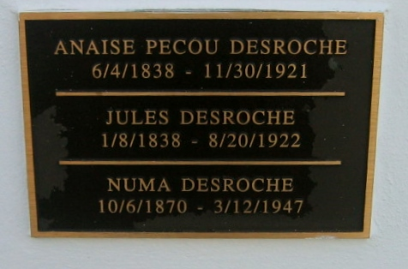

Photo by Bobby

Desroches, Jules, Pvt. Co. A. 18th La. Infty. En. Oct. 3rd, 1861, Camp Moore, La. Present on all Rolls to Feb., 1862.

Roll for May and June, 1862, Absent, sick, at Gen. Hospl. Regtl. Return June, 1862,

Absent, sick, at Hospl. since May 11th, 1862. Sent to Jackson or Holly Springs, Miss.

Roll for July and Aug., 1862, Present

Federal Rolls of Prisoners of War, Captured and paroled Labadieville, La., Oct. 27th, 1862.

Roll for Jan. and Feb., 1863, Absent, taken prisoner at Texana, Oct. 27th, 1862. 18th Regiment Louisiana Infantry  
St. James Rifles (St. James Parish): Company A.

Researched by Mike King