Albert Desselle
November 6, 1943 – June 24, 2018

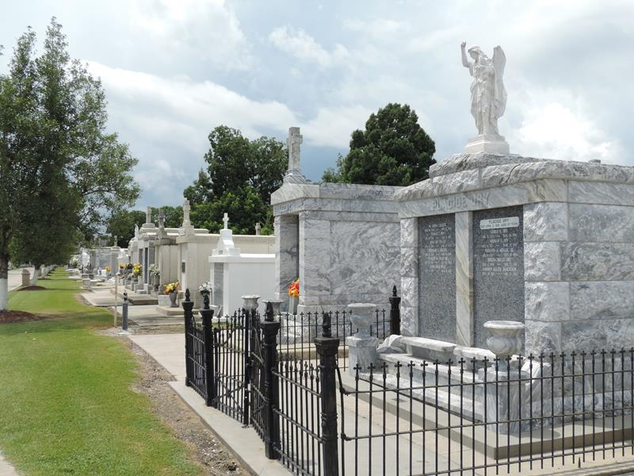

Albert "Cap" Desselle, 74, a native of Garyville and a resident of Reserve, passed away peacefully at 5:33 p.m. on Sunday, June 24, 2018.
Visitation will be held at 8:15 a.m. on Friday, June 29, at Our Lady of Grace Catholic Church, 780 La. 44, Reserve, La. Recitation of rosary will begin at 9 a.m. followed by Mass at 10 a.m., with the Rev. Christopher Chike Amadi officiating. Burial will follow in St. Peter Catholic Cemetery.
He is survived by his wife, Dolores Harris Desselle; sons, Albert Desselle III (Jeanta) and Kenneth Desselle; nine grandchildren; nine great-grandchildren; and a host of other relatives and friends.
He was preceded in death by his daughter, Bridget Ann Desselle; parents, Albert Jr. and Marie Lieteau Desselle; brother, Percy Joseph Desselle;
paternal grandparents, Albert and Rosie Boyer Desselle; and maternal grandparents, John and Marie Lieteau.
He was retired from Shell Oil Company.
Arrangements by Jones Funeral Home of Houma.
Houma Today & The Daily Comet, Terrebonne Parish, Louisiana
June 26 to June 27, 2018

