Malcolm J. Donaldson

November 22, 1923 – November 13, 2005

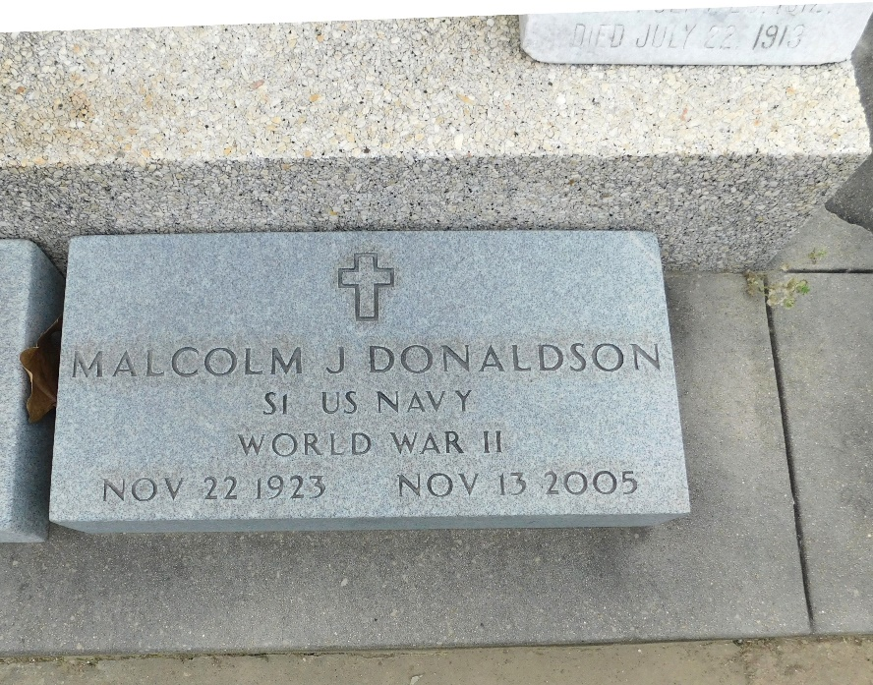

Photo by Mary Agnes Hammett

Malcolm J. (Mac) Donaldson On Sunday, November 13, 2005.

Beloved Husband of The Late Loriet Haik Donaldson. Father And Father-In-Law Of Donna Lynn And Cogan Fulton, Leslye And The Late Darryl J. Ellerbee, Malcolm J. (Mac) Jr. And Pam Donaldson, Taft And Tassy Donaldson And The Late Henry Donaldson. Grandfather Of Joey, Trace And Ashley Donaldson, Michelle Landry, Darryl, Jr., Jack And John Ellerbee, Beth E. Sullivan, Carolyn And Kathryn Fulton And Esther F. Black And Adrienne F. Haaga. Also Survived By 12 Great Grandchildren.

Son Of The Late Henry And Denise Maurin Donaldson. Brother Of The Late Beulah D. Rauchenbach, Edna Mae D. Jacob And Twin Brother Maurin C. Donaldson.

He Was Past Director Of The St. John Sugar Queen Pageant; President Of The St. John United Appeal; Commander Of The Reserve VFW Post And Founding Director And President Of The St. John Theater. Age 81. A Native And Resident Of Reserve.

Relatives And Friends Of The Family were Invited To Attend Services.  
Visitation was At Millet-Guidry Funeral Home, Laplace On Tuesday, November 15,2005 Followed By Religious Services At St. Peter Catholic Church, Reserve, La. Burial was In St. Peter Cemetery, Reserve, La.

Unknown source