Tony Dottolo

October 24, 1925 – August 20, 2010

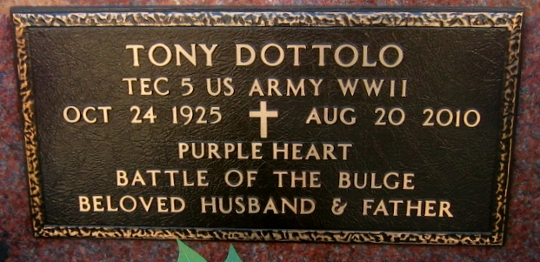

Photo by Bobby

Tony Dottolo passed away on Friday, August 20, 2010.

Beloved husband of Dolores Delaneuville Dottolo. Father of Glenn Dottolo and wife Angie and Debbie Dottolo Miller and husband Sam. Grandfather of Jimmy Dottolo, Rozi Miller Schoen, Bryan Dottolo, Natalie Miller, Kevin Dottolo and Sammy Miller. Great-grandfather of Carson Dottolo, Ava and Michael Schoen. Son of the late Paul and Helena Dottolo. Brother of Antoinette Rollo, Mary Accomando and the late Felix, Peter and Frank Dottolo.

He was an Army Vet of WWII who received the Purple Heart in the Battle of the Bulge. He was a kindhearted and compassionate man and deeply devoted to his Catholic Faith. He was a special man who touched the lives of all that knew him. Age 84. A native of Independence, La and resident of LaPlace, La.

Relatives and friends, also employees of St. John the Baptist Parish are invited to attend services. Visitation at St. Joan of Arc Catholic Church, 529 W. 5th St., LaPlace, La., on Monday, August 23, 2010 from 9:30 am. 11:30 am. Followed by a Mass at 11:30 am. Burial in St. Peter Cemetery, Reserve. Arrangement by Millet-Guidry Funeral Home, LaPlace, La.

The Times-Picayune, New Orleans, Louisiana

Aug. 22, 2010