Joseph Harvey Dufour

November 21, 1957 – September 16, 2010

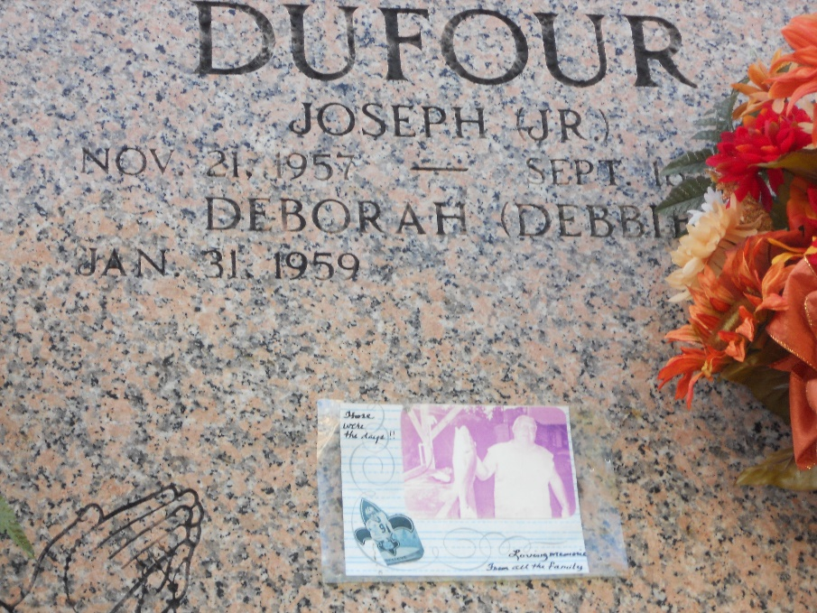

Photo by Team T-Lo

Joseph H. Dufour passed away on Thursday, September 16, 2010.  
  
Beloved husband of Debbie Emboulas Dufour. Father of Christopher (Charlotte) and Curtis Dufour. Grandfather of Angela Dufour. Son of the late Harvey and Lillian Dufour. Brother of Dewey (Vilmis), Samuel (Vickie) and Alvin (Mary) Dufour, Margie (Joe) Kennedy, Katherine (Signa) DeSota, Shirley (Butch) Jones, Lucille (Abel) Zerangue, Loretta (Leland) LaGrange and Janet (Laniel) Guillot. Age 52. A native of Plaucheville, La. and a resident of Montz, La.  
  
Relatives and friends are invited to attend services. Visitation at Millet-Guidry Funeral Home, 2806 W. Airline Hwy, LaPlace, La. on Monday, September 20, 2010 from 9:00 AM to 11:00 AM. Followed by a Mass at the Funeral Home Chapel at 11:00 AM. Burial in St. Peter Cemetery, Reserve, La.

The Times-Picayune, New Orleans, Louisiana

September 18, 2010