Albert J. Dufresne

June 22, 1879 – December 29, 1964

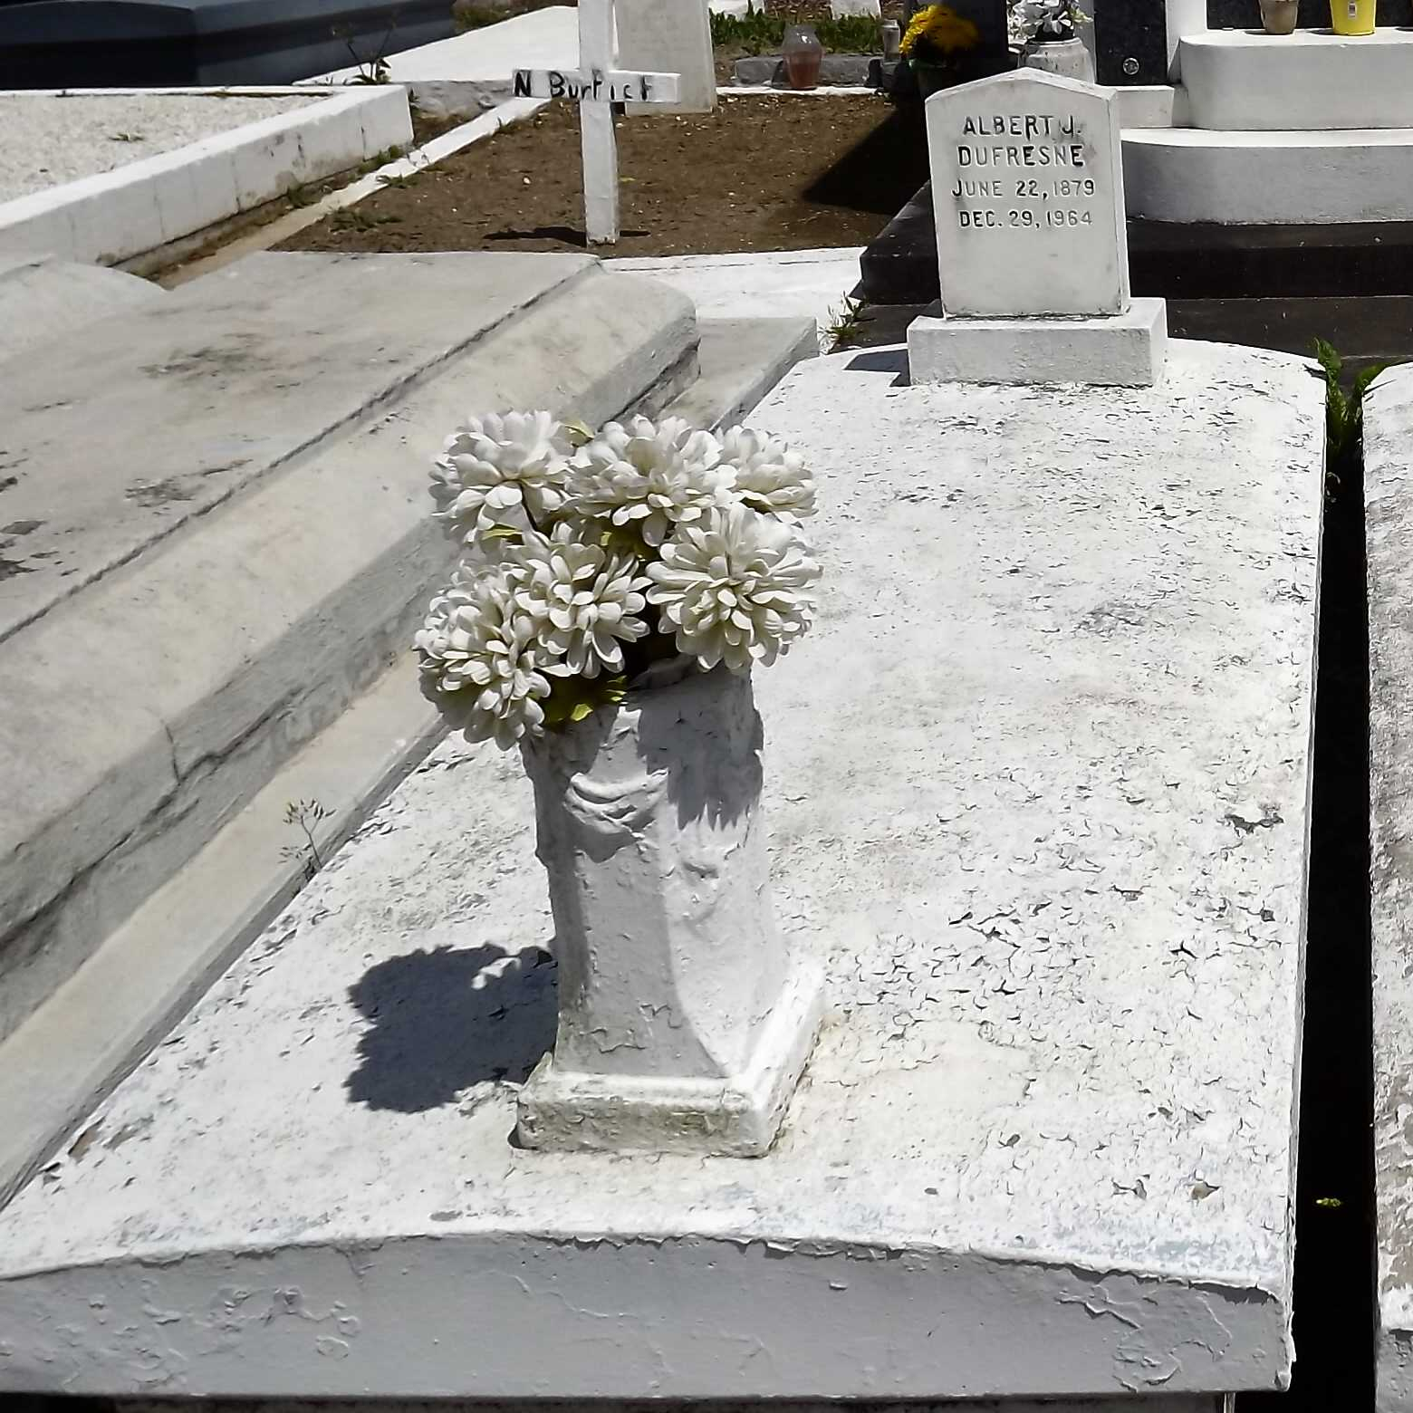

Photo by Mary Agnes Hammett

DUFRESNE - On Tuesday, December 29, 1964, at 2:18 o'clock p.m., ALBERT J DUFRESNE, husband of the late Louise Cambre, father of Mrs. Henry Luquette of Gramercy, La, Clarence Dufresne of Montgomery, Ala, Henry and Wilton Dufresne of Laplace, La, Mrs. Paul Richard and Mrs. Bob Landry of Norco, La, Mrs. James Hanson of Martinez, Calif, and the late Mrs. N. A. Millet and Mrs. Emile Black; age 85 years; a native of Reserve, La, and a resident of Montz, La.

Relatives and friends of the family are invited to attend the funeral. Services from Millet funeral home, Laplace, La, on Thursday, December 31, 1964 at 9:30 o'clock a.m. Religious services at Sacred Heart Church, Norco, La, at 10 o'clock a.m. Interment St Peter Cemetery, Reserve, La.

The Times-Picayune, New Orleans, Louisiana

December 30, 1964, p. 2