Etiennette (Hymel) Dufresne

July 4, 1916 – September 29, 2004

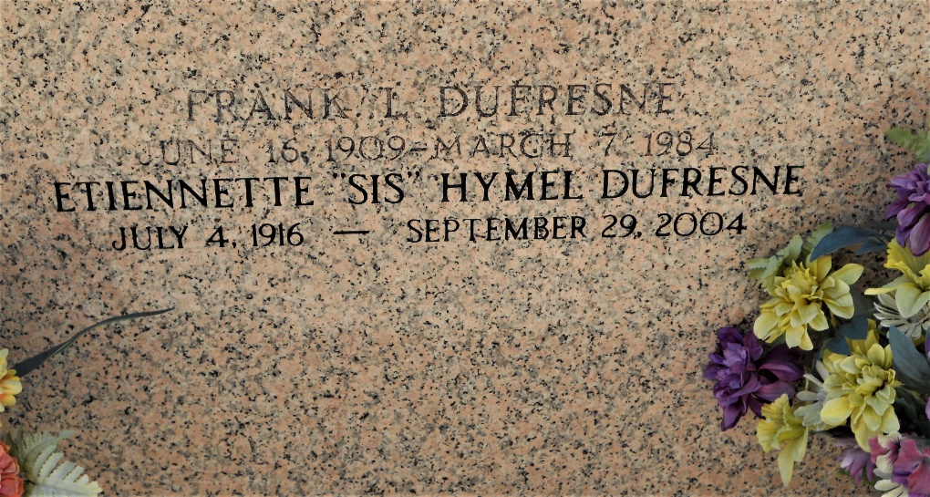

Photo by Team T-Lo

Etiennette (Sis) Hymel Dufresne, a native and resident of Laplace, Louisiana, died on Wednesday 29 Sep 2004 at 9 a.m. at age 88 years.

She was the wife of the late Frank Dufresne and mother and mother-in-law of Jennifer and Warren Bergeron Jr and Richard and Debbie Dufresne. Also survived by three grandchildren and one great grandchild. She was the daughter of the late Thomassin and Bertha Madere Hymel and the sister of the late Lorraine Kleinschmidt, Leona Braud, Hilda Nunn, Josephine Brady, Edith Bourgeois, Odette Hymel, France Madere, Paul, Etienne, Lionel, and Jules Hymel.

Services were Friday 1 Oct 2004 at St Joan of Arc Catholic Church, Laplace, with interment in St Peter Cemetery, Reserve, Louisiana.

The Times-Picayune, New Orleans, Louisiana

September 30, 2004