Linda (Hotard) Dufresne

May 22, 1943 – February 20, 2002

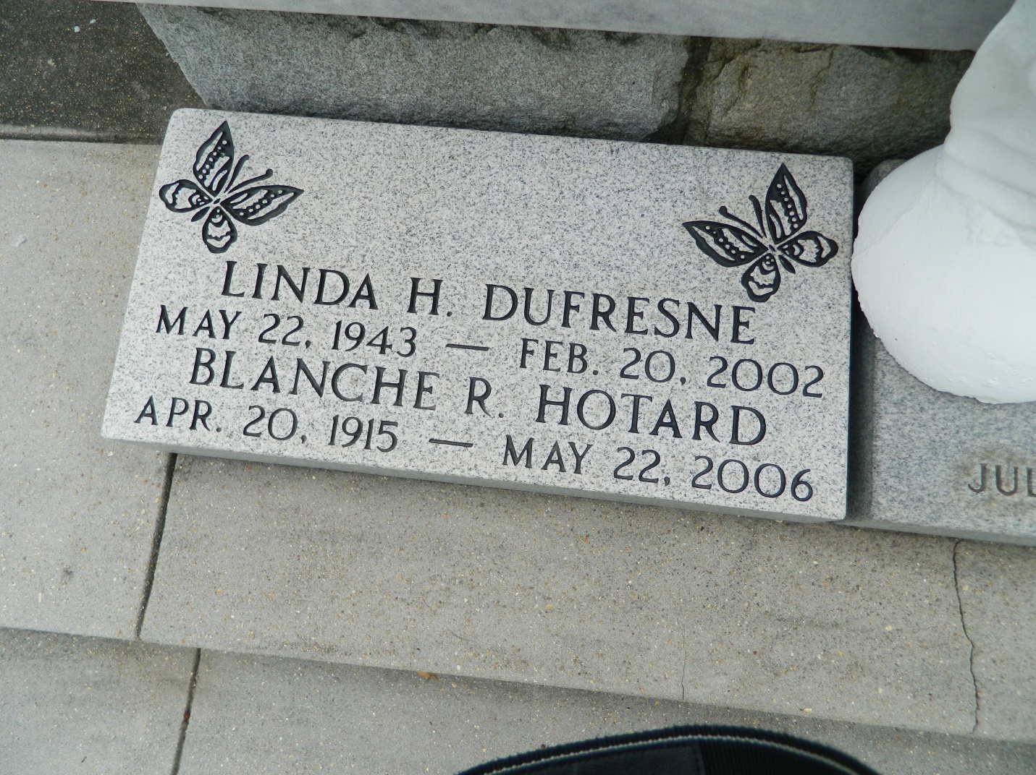

Linda Hotard Dufresne on Wednesday, February 20, 2002 at 6:20 p.m. Beloved wife of Barry M. Dufresne. Mother of David (Red) Ayme of Bradenton, FL. Daughter of Blanche Hotard and the late Simon (Chico) Hotard. She worked for 35 years in the sugar industry as an administrative assistant at Godchaux-Henderson Refinery and Colonial Sugars. Age 58. A native and resident of Reserve.   
 Relatives and friends of the family are invited to attend the funeral services at MILLET-GUIDRY FUNERAL HOME, 2806 W. Airline Highway, LaPlace on Saturday, February 23, 2002 followed by religious services at St. Peter Catholic Church, Reserve at 10:00 a.m. Burial in church cemetery. Visitation from 5:00 p.m to 10:00 p.m. on Friday and from 8:00 am until services on Saturday. In lieu of flowers, donations preferred to the Lance Armstrong Foundation, P. O. Box 425, Reserve, LA. 70084

Times-Picayune, The (New Orleans, LA) — Friday, February 22, 2002

Contributed by Jane Edson