Louise Bernadette (Cambre) Dufresne

July 13, 1879 -December 16, 1952

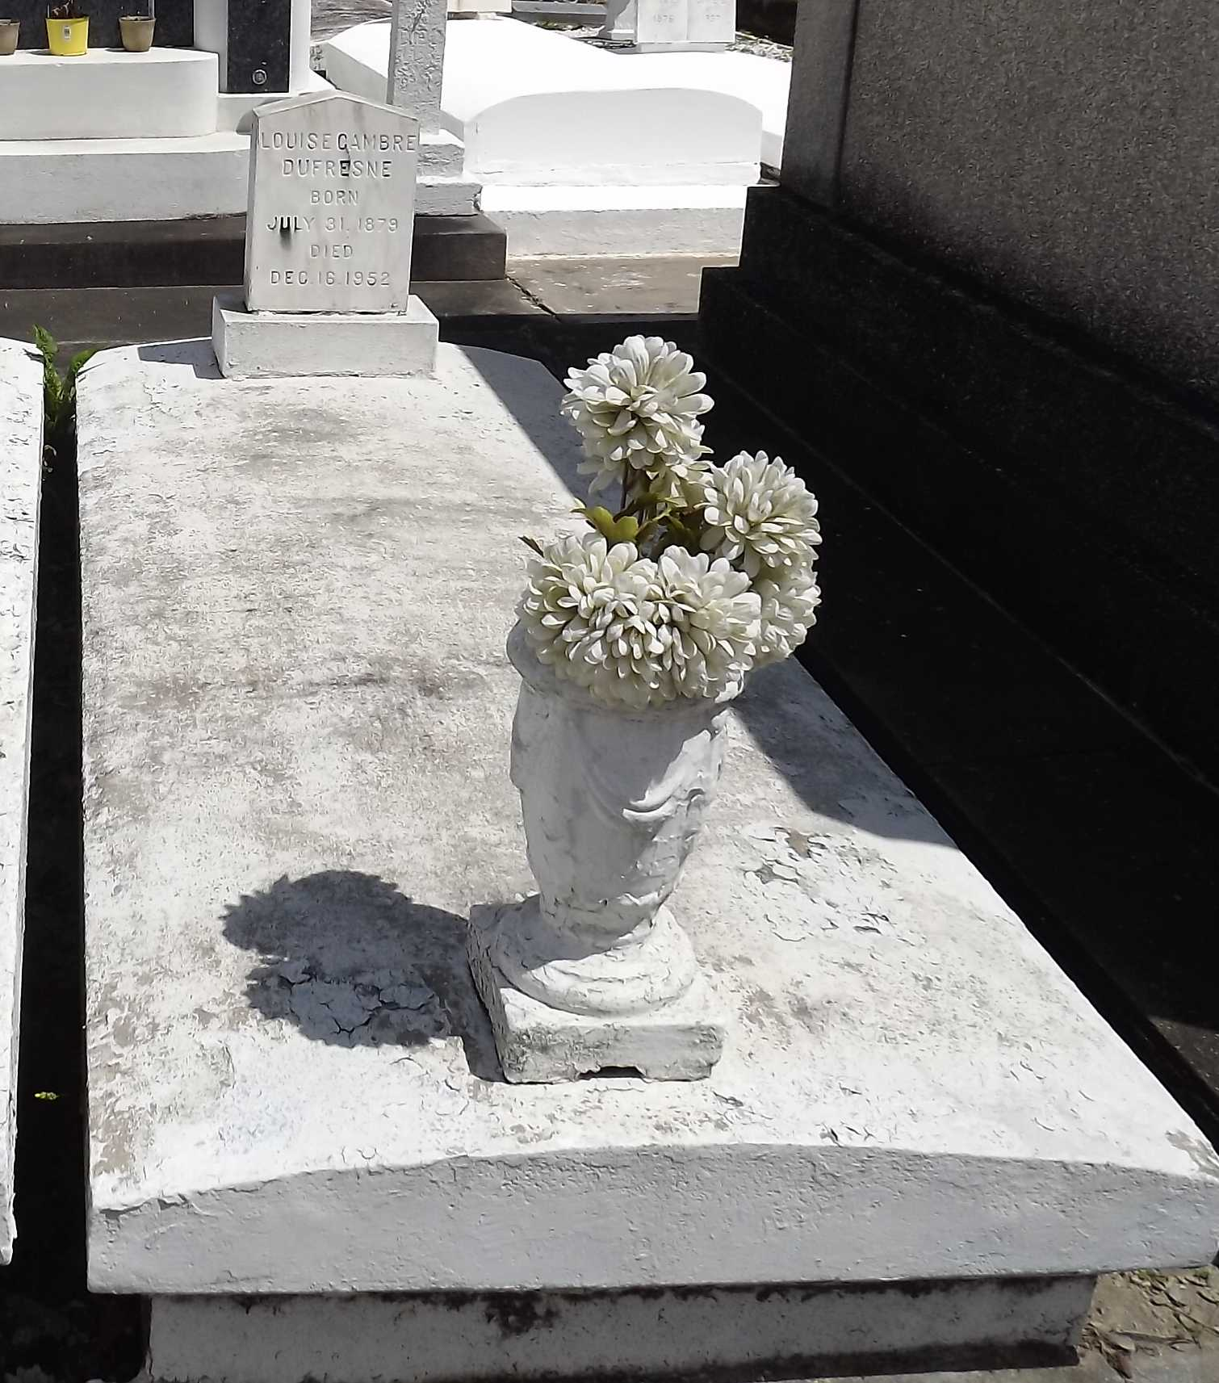

Photo by Mary Agnes Hammett

DUFRESNE - On Tuesday, December 16, 1952, at 2:15 o'clock a.m., LOUISE CAMBRE, beloved wife of Albert Dufresne, mother of Mrs. Henry Luquette, Mrs. Nemoure Millet, Mrs. Emile Blank II, Mrs. Paul Richard, Mrs. Bob Landry, Mrs. Robert Hanson and Clarence, Henry and Wilton Dufresne, also survived by 25 grandchildren and six great grandchildren; age 73 years.

Relatives and friends of the family are invited to attend the funeral from Millet Funeral Home, Reserve, La, on Wednesday, December 17, 1952, at 9:30 o'clock a.m., followed by religious services at St Peter's church, Reserve, La. Interment in St Peter's cemetery, Reserve, La.

The Times-Picayune, New Orleans, Louisiana

December 17, 1952, p. 2