Roy A. Dufresne

June 12, 1917 – December 27, 2005

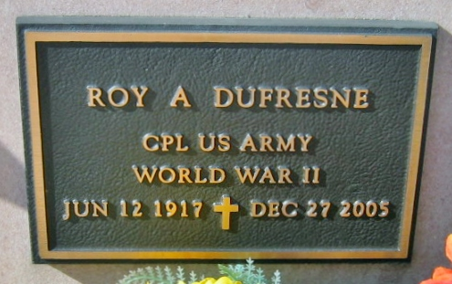

Photo by Bobby

Roy A. Dufresne on Tuesday, December 27, 2005 at 2:55 am.

Beloved husband of the late Juanita V. Dufresne. Father and father-in-law of Juanita and Justin Calvo and Elaine and Jake Maus. Son of the late Ulysse and Laura Dufresne. Brother of the late Ulysse Jr., Sydney and Ethel Dufresne. Grandfather of Roxanne Dauzat, Troy Dubreuil, Lee and Theresa Maus and Jennifer Breaux. Also survived by 4 great-grandchildren. Godfather of Emily Matherne. Also survived by a host of nieces and nephews. Age 88. A native and resident of Reserve.

Relatives and friends of the family also members of American Legion Post 366 Destrehan and American Legion Post 159 Reserve and Shell Oil employees are invited to attend services. Visitation at Millet Guidry Funeral Home, 2806 W. Airline Hwy, Laplace, on Wednesday, December 28, 2005 from 5:00 pm-10:00 pm and on Thursday morning from 8:00 am-9:00 am. Followed by religious services at St. Peters Catholic Church, Reserve at 10:00 am. Burial in church cemetery.

The Times-Picayune, New Orleans, Louisiana

December 28, 2005