Wilton M. DuFresne

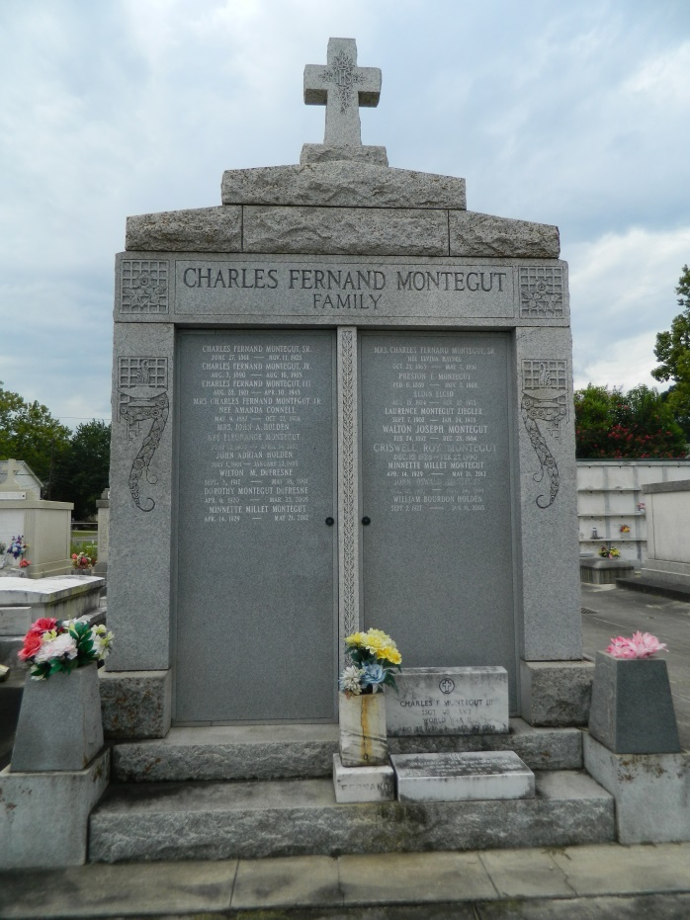 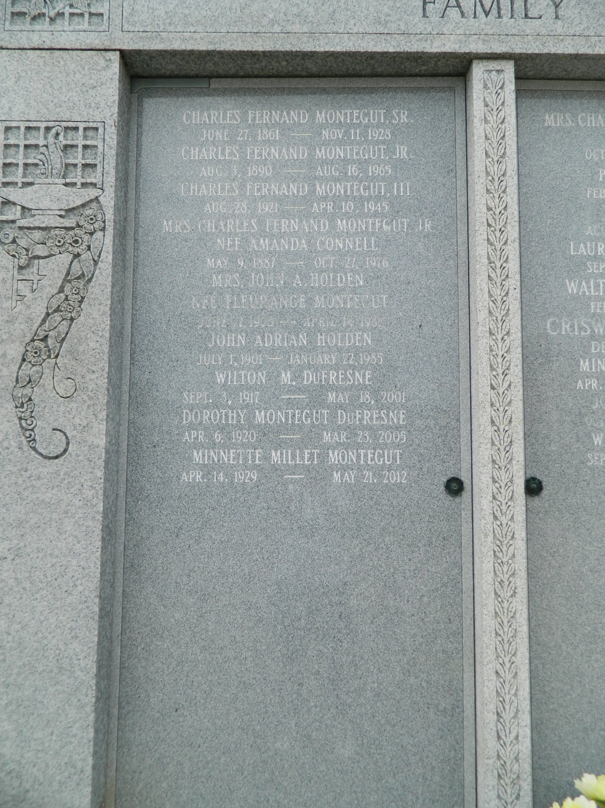

Wilton (BooBoo) Dufresne on Friday, May 18, 2001 at 12:05 p.m. Beloved husband of Dorothy Montegut Dufresne. Son of the late Albert and Louise Cambre Dufresne. Brother of Adele Richard of Norco, LA, Marie Louise Hanson of Martinez, CA, the late Clarence and Henry Dufresne, Vivian Landry, Winnie Millet, Thelma Blank and Evena Luquette. Mr. Dufresne was an employee of Shell Oil Co. for 33 years. He was a WW II veteran and a member of V.F.W. Post 3337 and also a member of Woodsmen of the World. Aged 83 years. A native and resident of LaPlace, LA.   
 Relatives and friends of the family are invited to attend the Funeral Services at St. Joan of Arc Catholic Church, LaPlace, LA on Monday, May 21, 2001 at 11:00 a.m. Interment St. Peter Cemetery, Reserve, LA. Visitation 9:00 a.m. Monday until services.   
 In lieu of flowers, donations to St. Joan of Arc School or Church Fund, 529 W. 5th Street, LaPlace, LA 70068, requested.  MILLET-GUIDRY FUNERAL HOME in charge.

Times-Picayune, The (New Orleans, LA) - Saturday, May 19, 2001

Contributed by Jane Edson