Antoine Melancon Duhe

March 8, 1919 – July 26, 2010

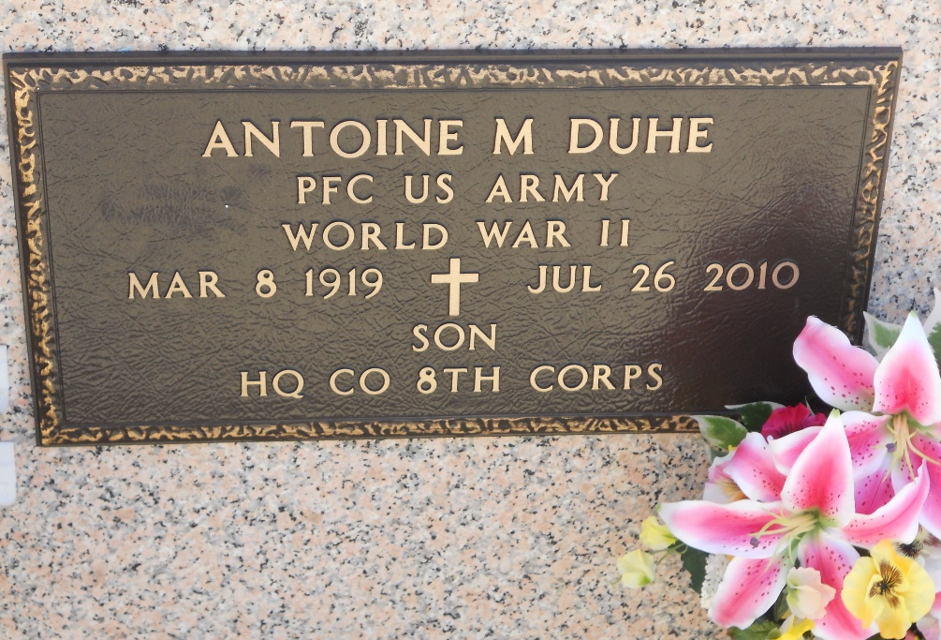

Photo by Team T-Lo

Antoine M. (Son) Duhe passed away on Monday, July 26, 2010.

Husband of Rowena Michel Duhe for 64 yrs. Father of Carolyn D. Applewhite and Barbara D. Galatas Oubre and husband Michael. Father-in-law of the late William (Skeet) Galatas and Wayne Applewhite. Grandfather of Shannon Breaud and Teresa, Scott Galatas and Theresa, Rachel Galatas Brennan and Robert and Dawn Breaud Lucia and Joey. Great-grandfather of Whitney, Alex, Abbey and Mallory Brennan, Ryan and Zachary Breaud, Marissa and Katie Galatas.

Son of the late Ambrose (Tattoon) and Bernadette Duhe. Brother of Lawrence, Ronald (Poncho) and Errol (Sec) Duhe, Claire Michel and the late Jules, Albert and Jean Duhe, Bernadette Oubre, Aline Gueret and Ann Torres.

Times-Picayune, New Orleans, Louisiana

July 28, 2010