Bernadette (Battard) Duhe

August 29, 1892 – October 2, 1967

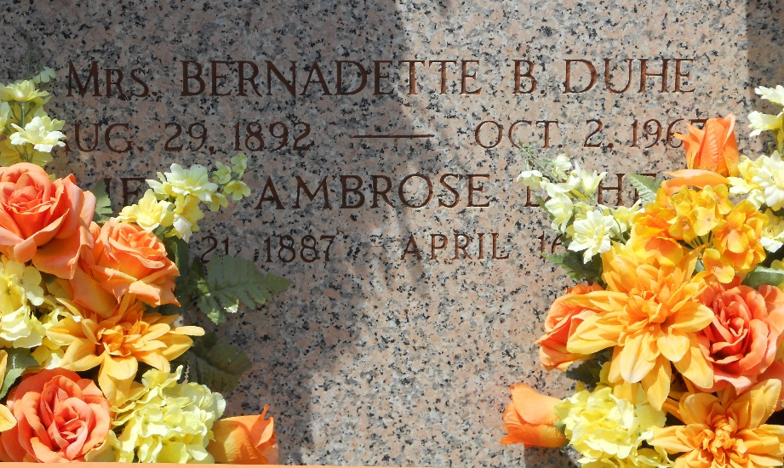

Photo by Team T-Lo

Age 75 years, a native and resident of Reserve, Louisiana. Wife of Ambroise (Tatoon) Duhe, mother of Jules and Antoine, Ronald, John and Lawrence, all of Reserve, Albert Duhe of Lake Jackson, Texas, Errol Duhe of Thibodaux, Louisiana, Mrs. Bernadette Oubre of Garyville, Louisiana, Mrs. Ann Torres of Laplace, Louisiana, Mrs. Claire Michel and Mrs. Aline Gueret of Reserve. Sister of Mrs. Remy Poche of Lutcher, Louisiana, Mrs. Victor Ford and Mrs. Jimmy Haley of New Orleans.

Services were Tuesday 3 Oct 1967 at St Hubert Church, Garyville, with interment in St Peter Cemetery, Reserve.

The Times-Picayune, New Orleans, Louisiana

3 Oct 1967