Bruce Martin Duhe Jr.
November 3, 1954 – November 24, 2023

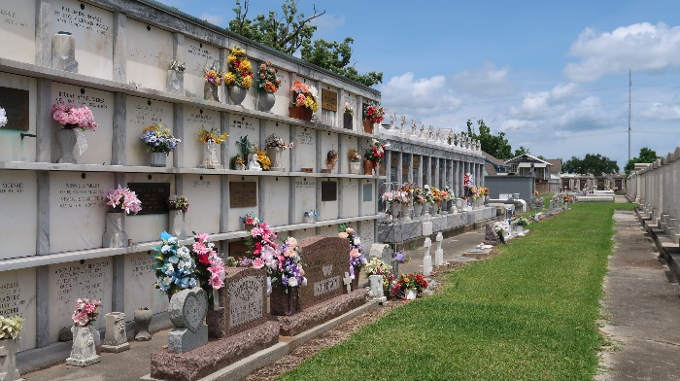

Bruce Martin Duhe' Jr., age 69, of Gonzales, La passed away on Friday, November 24, 2023 at the Fidelis House in Denham Springs, La. He was a sales consultant for Layne Christensen. Bruce was a great story teller. He enjoyed gardening and being outdoors. He loved watching LSU and the Saints. He loved his family, but most of all he really loved being a grandfather.
He is survived by his wife, Milissa Guichard Duhe'; daughters, Andrea Duhe' and Casey Duhe' Sevario (T.J); son, Kevin Duhe' (Rachel); grandchildren, Cole Sevario, Lucas Sevario, Ella Sevario, Rylee Duhe', and Sutton Duhe'; sisters, Barbara Hill (Lou), Diane Duhe' Feagley (Chris); brothers, Bryan Torres (Mary), Greg Duhe' (Donna) and Brian Duhe'; and sister-in-law, Patricia Torres.
He was preceded in death by his parents, Bruce Duhe' Sr. and Sandra Torres Duhe', his grandparents and several aunts, uncles and cousins.
A memorial visitation for Bruce will be held Saturday, December 9, 2023 from 9 AM until the Memorial Mass at 11 AM at Holy Rosary Catholic Church, 44450 LA Highway 429, St. Amant, La. 70774. Bruce will be laid to rest in St. Peter Cemetery, 1550 LA-44, Reserve, La.
A special thanks to his amazing caregivers, Alisha, Ms. D., Ms. Pam, Laquisha, Altonisha, Destini, Cartrice, Christine and Jacklyn, Erica, nurses, Samantha and Leslie and to the wonderful people at Charlie's Place, Songi, Rachel and Tee.
In Lieu of flowers donation can be made to Charlie's Place Alzheimer's Services at http://alzbr.org/donate or St. Jude Children's Research Hospital at stjude.org/donate.
In honor of Bruce please wear Purple and Gold or Black and Gold. Ourso Funeral Home in charge of arrangements.

Dignity Memorial

