Dione (Gant) Duhe

December 4, 1972 - October 14, 2009

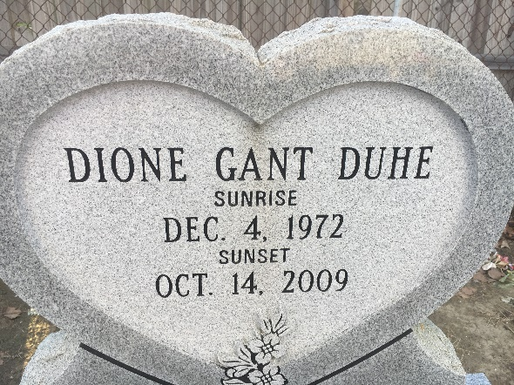

Photo by Team T-Lo

Dione Gant Duhe, at River Parishes Hospital, on Wednesday, October 14, 2009.

Beloved wife of David Duhe. Daughter of Donald Gant, Sr. and the late Deborah James. Stepdaughter of Cynthia Gant and Donald James. Stepmother of Kirsten Darville. Sister of Donald Gant, Jr., Demond and Desmond James, Dustin Gant and LaTonya Speaks. Granddaughter of Ida Stanton (late Thomas Stanton) and Isaac Gant, Sr. (late Gracie B. Gant). Also survived by a host of aunts, uncles, cousins, nieces, nephews, and many friends. A native and resident of Reserve, LA. Age 36 years.

Relatives and friends of the family, also pastor, officers and members of the Greater New Plymouth Rock B.C. and neighboring churches and Class of East St. John H.S. "1990" are invited to attend the Funeral Services on Monday, October 19, 2009 at 11:00 a.m. from the Greater New Plymouth Rock B.C, 110 N.W. 13th, Reserve, LA. Rev. David B. Carter, officiating. Visitation at the Church after 9:00 a.m. Entombment St. Peter Catholic Church Mausoleum, Reserve, LA. The Baloney Funeral Home, LLC 399 Earl Baloney Dr., Garyville, LA Information: (985) 535-2540 In Charge of Arrangements

The Times-Picayune, New Orleans, Louisiana

October 18, 2009