Dolores (Gueret) Duhe
January 29, 1926 – March 25, 2021

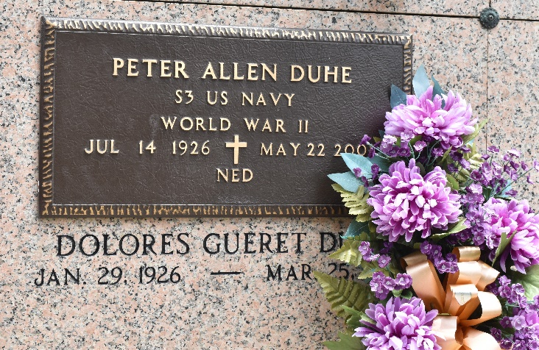
Photo by Team T-Lo

Dolores Gueret Duhe passed away on Thursday, March 25, 2021 peacefully at home surrounded by her children at the age of 95.
She was a native of Reserve, LA and a resident of Garyville, LA. Dolores was a devoted wife, mother, and grandmother. She was an avid gardener and most remembered by her cooking, especially her crawfish bisque.
She was preceded in death by her husband, Peter "Ned" Duhe; parents, Abraham and Jeanne Gueret; brothers, Henry Gueret, Lawrence Gueret, Charles Gueret, and Abraham Gueret; sisters, Anna Mae Oubre, Bertha Aubert, Odelia Gagliana, Lucres Roussel, and Hazel Gueret.
She is survived by her four children, Gene Duhe (Tami), Gwendolyn "Penny" Brock (Gary), Mary Summers (LeDaine), and Peter Duhe; nine grandchildren, Jason Brock (Annie), Casey Duhe (Jessica), Jennifer Brock (Ben), Michael Summers (Katina), Blake Duhe (Megan), Michelle Peoples (Daniel), Mitchell Summers (Marie), Taylor Duhe, and Ashley Duhe (Jovi); nine great-grandchildren, Baron and Drake Brock, Demi Powell, Allie Felger, Preston Summers, Jessie and Jennie Peoples, Cullen Duhe, and Lincoln Duhe; great step-grandchildren, David and Madison Peoples, Peyton and Brody Anderson, and Riley and Keller Powell.
The family would like to give a special thanks to Chikita Perrilloux and St. Joseph Hospice for their care and devotion.
Relatives and friends are invited to attend the visitation on Wednesday, March 31, 2021, held in St. Hubert Catholic Church, 176 Anthony F. Monica St., Garyville from 9:00 a.m. to 11:00 a.m. and Funeral Mass commencing at 11:00 a.m., followed by interment at St. Peter Cemetery. Arrangements by Millet-Guidry Funeral Home.
Millet-Guidry Funeral Home, LaPlace, Louisiana
March 27, 2021

