Dorothy (Joseph) Duhe

September 29, 1941 – October 16, 2020

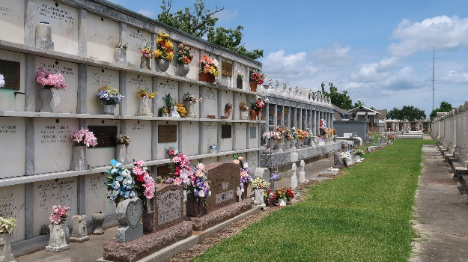

Dorothy Joseph Duhe was born on September 29, 1941 to the union of the late Olivia and Fred Joseph in New Orleans, LA. On October 16, 2020, she departed her earthly life and gained her eternal wings.  
 Dorothy confessed her belief in the Lord Jesus Christ at an early age. On June 22, 1952, she was baptized in the Mississippi River by the late Reverend George Washington of Plymouth Rock Baptist Church. During her Christian journey, she served many years as an Usher. Her service at Greater New Plymouth Rock Baptist Church as a faithful member under Reverend David B. Carter continued until her illness prevented her from attending.  
 Dorothy was educated in St. John the Baptist Parish Public School System; she graduated from Fifth Ward High School in Reserve, LA in 1960. After graduation she attended Southern University in Baton Rouge, LA where she received a Bachelor of Arts in Elementary Education in 1965. Upon graduation she returned to the place where she received her early education and devoted 32 years of her life to teaching in the St. John the Baptist Parish Public School System.  
 Dorothy was an avid shopper and would spend countless hours shopping for clothes and shoes and wouldn’t stop until she found as many bargains as she could. She was also a lover of hats; her collection was so large that she had a hat for every day of the year.  
 Although she had a tremendous love for shopping, her love of the New Orleans Saints football team far outweighed it. Every year she would always say that the Saints were going to the Super Bowl; long before they even had a chance of making it there. On the night of February 7, 2010, Dorothy was home alone watching the game that she had envisioned for so many years. It was her desire to watch it alone because she said she didn’t want to be distracted by ANYTHING.  
 Dorothy leaves to cherish her memory, her daughter and son, Darlinta Duhe Garrison (Lawrence) and Rodrick Duhe (Trayvonia), both of LaPlace, LA.; her grandchildren Philip Age, III, Darvelle Charles, David Cook, Jr., Darielle Cook, Nathaniel Duhe and Tate Duhe; 10 great-grandchildren; a devoted sister, Elois Joseph; and a host of nieces, nephews, relatives and friends.  
 She was preceded in death by her parents, Olivia and Fred Joseph ; 2 brothers, Junius Noel and Homer Joseph; one sister, Olivia Morris; one great- grandson, Kacen Charles; and her goddaughter, Toneka Walker Terry.  
 Family and friends are invited to attend a celebration of life on Saturday, October 24, 2020 at New Wine Christian Fellowship 1929 W Airline Hwy, LaPlace, LA 70068. Viewing will be held from 10am to 12pm, followed by a service at 12pm. Entombment to follow at St. Peter Catholic Church Cemetery in Reserve, LA.

Treasures of Life Funeral Services, Gramercy, Louisiana

October 20, 2020