George Leo Jr.

June 28, 1931 – January 11, 2014

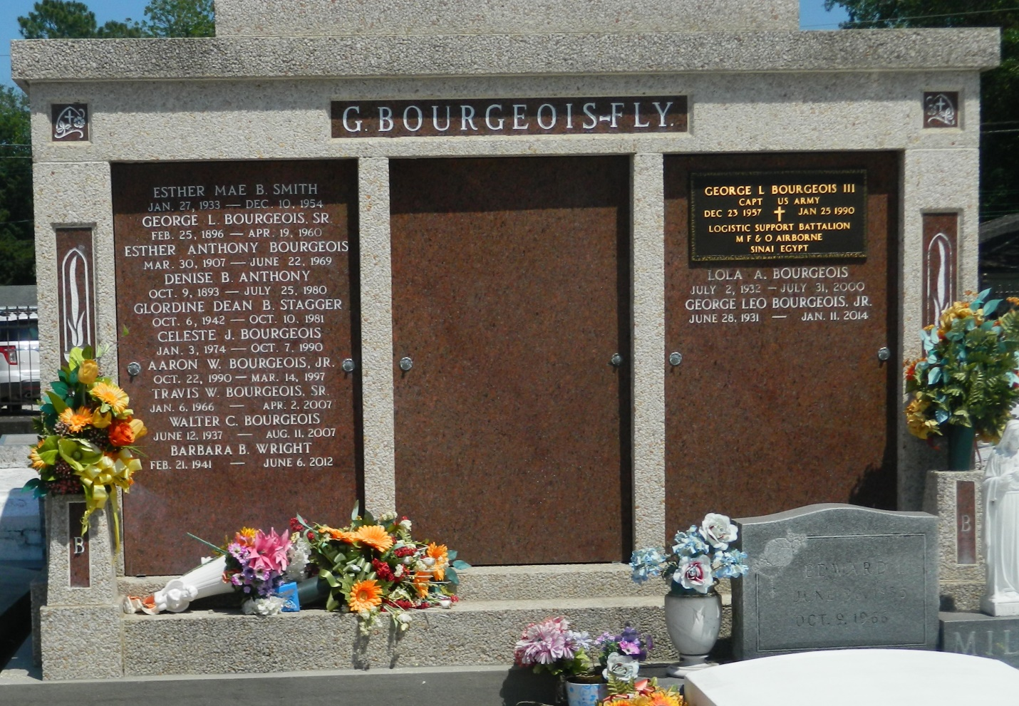

GEORGE L. BOURGEOIS, JR. on Saturday, January 11, 2014 at his home in LaPlace, LA  
 Son of the late Hesther Anthony and George L. Bourgeois, Sr. Beloved husband of the late Lola Mitchell Bourgeois. Father of Eric (Madeline) of Edgard, LA, Clinton (Velvet), Aaron (Kristin) of LaPlace, LA, Adrian (Marilyn) of Kenner, LA, Patrice (Louis) Austin of LaPlace, LA , the late Capt. George L., III and Travis Bourgeois. Father in law of Paula Bourgeois of Texas. Brother of Wallace Bourgeois of LaPlace, LA, the late Ester Mae Smith, Gloria Dean Staggers, Barbara Wright and Walter Bourgeois. Brother in law of Mercedes Bourgeois of LaPlace, Welman Staggers of Reserve, LA and Earl (Bernadine) Mitchell of Baton Rouge, LA. Also survived by a devoted cousin Sister John Mary Jackson, 20 grandchildren, 14 great grandchildren and a host of nieces, nephews, cousins, caregivers, other relatives and friends. Age 82 years. A native and resident of LaPlace, LA  
 Relatives and friends of the family, also priest and parishioners of Our Lady of Grace Catholic Church and School, Rising Star Baptist Church and all neighboring churches, Knights of Peter Claver Ladies Auxiallary Council and Court #73, EO Moss Grand Assembly #4, employees of Marathon Petroleum, EIU Electrical, St John the Baptist Parish Public Works, Department of Motor Vehicle, St John the Baptist Parish Judicial System, Labor Union #689, The Salvation Army and Embridge Trucking are invited to attend the Funeral Mass at Our Lady of Grace Catholic Church, 772 Highway 44, Reserve, LA on Saturday, January 18, 2014 at 10:00 AM. Father Christopher Amadi, Celebrant, Father Joseph Rodney Con-Celebrant. Interment St Peter Cemetery, Reserve, LA. Visitation at the above named church from 8:15 AM until Mass time.  
 SERVICED BY ROBOTTOM

Times-Picayune, The (New Orleans, LA) - Friday, January 17, 2014

Contributed by Jane Edson