Henry M. Duhe Jr.

July 6, 1954 – January 14, 2005

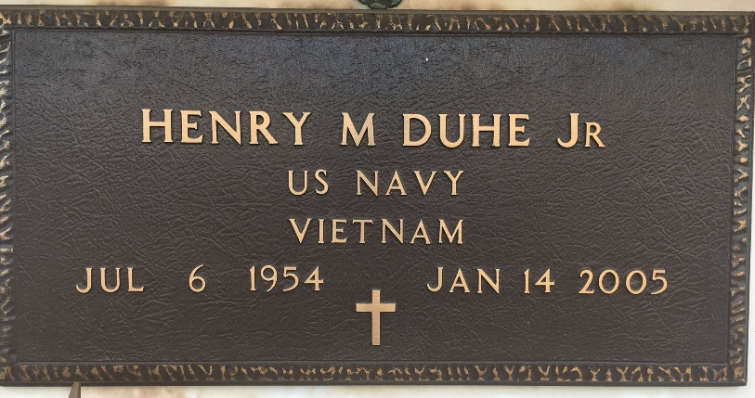

Photo by Team T-Lo

Henry (Tripe) Duhe, Jr. of LaPlace, La. at River Parish Hospital, LaPlace, La. on Friday, January 14, 2005.  
 Son of the late Henry and Elaine Duhe. A native of Garyville, La. and a resident of LaPlace, La. Age 50 years.  
 Relatives and friends of the family, also priest and parishioners of Our Lady of Grace Catholic Church, employees of Metropolitan Human Services District, Veterans Medical Center, Southern University, Class of Leon Godchaux '72' are invited to attend a Mass of Christian Burial on Monday, January 17, 2005 at 11:00am from the Our Lady of Grace Catholic Church, Reserve, La. Father Joseph Rodney, celebrant. Interment St. Peter Catholic Church Cemetery, Reserve, La. Visitation at the church after 9:00am.  
 The Baloney Funeral Home 399 Earl Baloney Dr., Garyville, La. 70051 (985) 535-2540 In charge of arrangements.  
  
Times Picayune, New Orleans, Louisiana

January 16, 2005