Jessie Elizabeth (Sutton) Duhe

September 19, 1898 – July 12, 1985

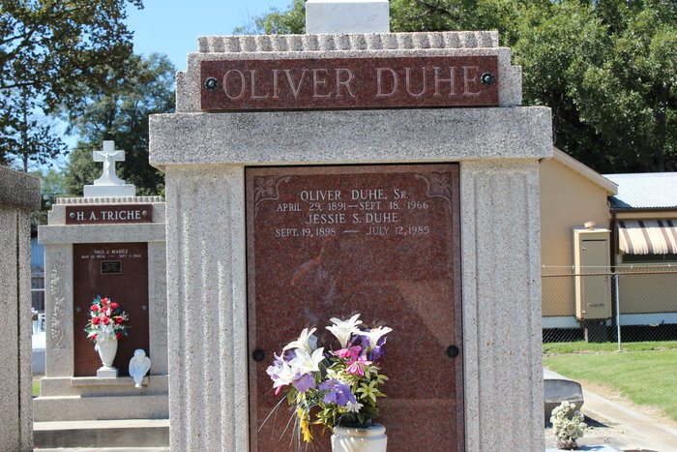

Jessie E. Duhe passed away on Friday, July 12, 1985 at 9:15 p.m., beloved wife of the late Oliver Duhe, Sr. of Reserve, LA, mother of Sylvester O. (Rusty) Duhe of Laplace, LA, Oliver Duhe, Jr. of New Orleans, LA, Lionel Duhe of Loranger, LA and Mary Anna Vicknair of Reserve, LA, sister of Antoinette Gleason and Florence Borne, both of Metairie, LA and the late John H., Edward, Martin and Oliver Sutton, Olive Brignoni, Gracie Putfark and Eleanora Kingsmill, also survived by 14 grandchildren and 13 great grandchildren, age 86 years, a native of New Orleans, LA and resident of Reserve, LA for the past 51 years.  
 Relatives and friends of the family are invited to attend the funeral services from Millet Funeral Home, Reserve, LA, on Monday, July 15, 1985 at 10:30 a.m., followed by religious services at St. Peter Catholic Church, Reserve, LA.   
Interment St. Peter Cemetery, Reserve, LA. Friends may call from 5:00 p.m. until 10:00 p.m. on Sunday, July 14, 1985, and from 8:00 a.m. until services on Monday.  
  
Times Picayune, New Orleans, Louisiana

July 14, 1985