Joseph Duhe
November 4, 1907 – June 2, 1972

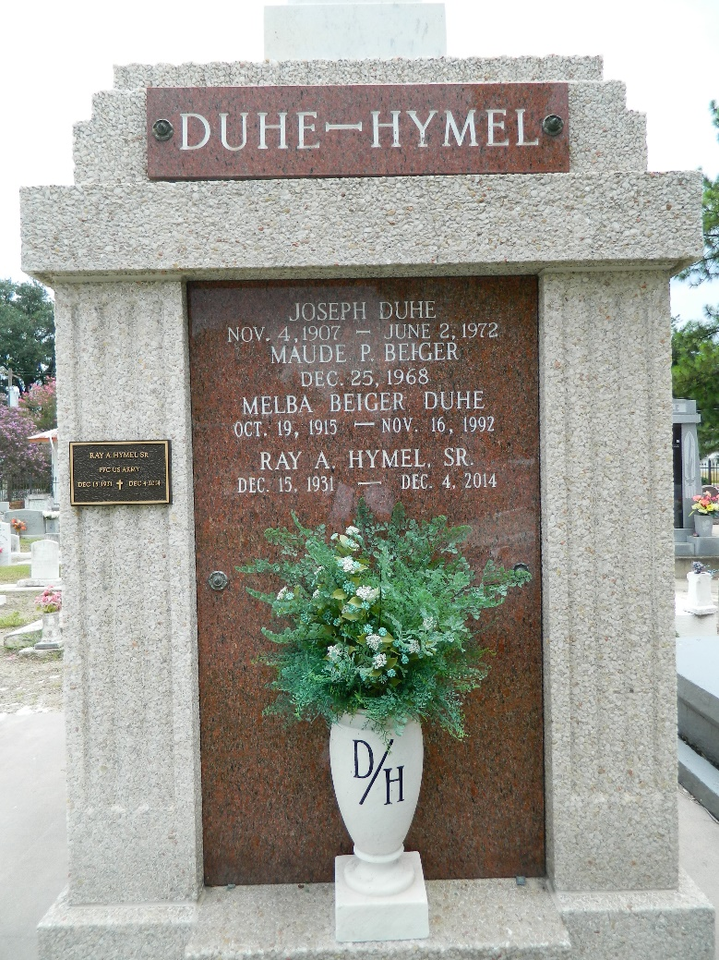

Age 64 years, a native and resident of Reserve, Louisiana. Husband of Melba Beiger, father of Mrs. Ray (Melba) Hymel of Reserve. Son of the late Gustave Duhe and Zoe Duhe, brother of Mrs. Guy Cambre of Laplace, Louisiana, Mrs. S R Smith of Bush, Louisiana, and the late Leon Duhe.

Services were Monday 5 Jun 1972 at St Peter Church, Reserve, with interment in St Peter Cemetery.
Times Picayune, New Orleans, Louisiana
June 3, 1972

