Justinien Duhe
April 7, 1872 – December 29, 1948

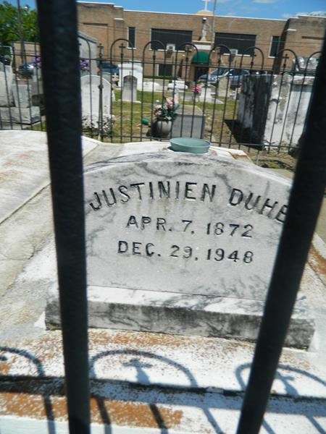

Justinien Duhe died at Destrehan, Louisiana, on Wednesday 29 Dec 1948 at 1:45 o'clock p.m.
He was the husband of Adele Ory and the father of Pascal and Eddie Duhe of Norco, Louisiana, D J Duhe of Destrehan, Lucien Duhe, Mrs. Loretta Klumpp, Mrs. Odile Lauterback, Mrs. Harman Blanchard and Mary Duhe of New Orleans, Leonce Duhe of Westwego, Louisiana and John Duhe of Los Angeles, California. Also survived by 26 grandchildren and 10 great grandchildren. Aged 77 years, a native of St John Parish, Louisiana, and a resident of Destrehan for 11 years.
Relatives and friends of the family, also employees of Shell Oil Refinery of Norco, Louisiana, and the Celotex Corporation of Marrero, Louisiana, are invited to attend the funeral which will take place from the Millet Funeral Home in Reserve, Louisiana, on Friday 31 Dec 1948 followed by religious services at St Peter's Church, Reserve. Interment in St Peter's Cemetery, Reserve.
Times Picayune, New Orleans, Louisiana
December 31, 1948, p. 2

