Lawrence William Duhe
November 6, 1930 – June 18, 2022

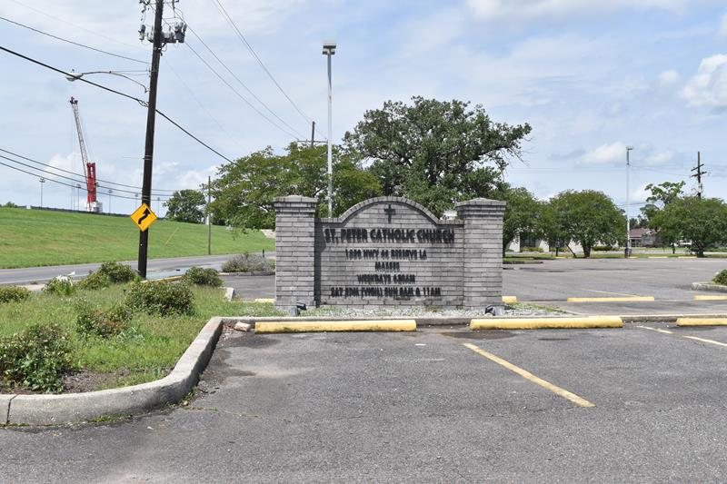

Lawrence William Duhe, Sr. passed away on Saturday, June 18, 2022 at the age of 91. He was a native and resident of Reserve, LA.
Beloved husband of the late Edna Mae Ockman Duhe. Loving father of Margie LaBranche (Eric), Gail White (Michael), Belinda Keating, Lynn Duhe and Lawrence “Larry” Duhe, Jr. (Carrie). Grandfather of Jonathan LaBranche (Ashley), Crystal White Oubre, Kelly Keating Boe, Curtis Keating, Hayley Duhe, Laura Duhe and Brandon Malmgren. Son of the late Bernadette Battard Duhe and Jean Ambroise Duhe. Brother of the late Jules “NuNu” Duhe, Bernadette “Seur” Oubre, Antoine “Son” Duhe, Albert Duhe, Aline Gueret, Jean “Tutoon” Duhe, Marie “Claire” Michel, Emily “Ann” Torres, James “Poncho” Duhe and Louis Errol “Seck” Duhe. Also survived by 5 great grandchildren and many nieces and nephews.
He was a proud Army veteran. He served in the Korean War for 18 months. He was a long time active member of the American Legion Post 159 and V.F.W. Post 5004. He was also a lifetime member of the Reserve Volunteer Fire Department.
He retired in 1987 after 30 years with the Reserve Post Office as a mail carrier. And for the last nearly 35 years you would often find him at Don's Country Store helping out and interacting with the customers. He had many friends in the community. He also spent most of his life hunting and fishing at the family camp, Tattoon's Hunting Club. He was a great family man. He lived a good life and will be missed by everyone.
Relatives and friends are invited to attend the Visitation and Funeral Mass at St. Peter Catholic Church, 1550 Hwy 44, Reserve on Saturday, June 25, 2022. Visitation will be held in church from 9:00 a.m. to 11:00 a.m. with the Funeral Mass to immediately follow at 11:00 a.m. Interment in St. Peter Cemetery, Reserve, LA.
Millet-Guidry Funeral Home, LaPlace, Louisiana

