Leonie (Millet) Duhe
June 21, 1892 – September 30, 1972

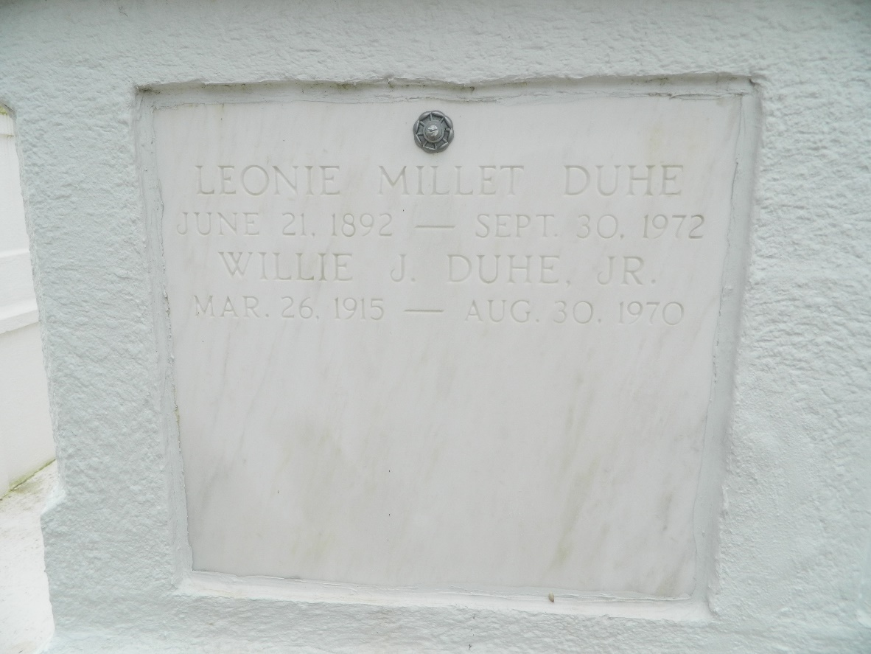

Age 80 years, a native and resident of Reserve, Louisiana. Wife of the late Willie J. Duhe Sr. and mother of Dr. Henry M. Duhe of New Orleans, Mrs. Paul (Genevieve) LaBiche, Paul, Harry B, Leon C, J Oswald and Mrs. Larry (Marvie) Boudreaux, all of Laplace, Louisiana, Harold Duhe of Marrero, Louisiana, Peter Duhe of Reserve, and the late Willie J Duhe Jr, Evelyn, Joyce, Dorothy, Sidney and Raymond Duhe.

Services were Monday 2 Oct 1972 at St Peter Church, Reserve, with interment in St Peter Cemetery, Reserve.
Times Picayune, New Orleans, Louisiana
October 2, 1972

