Marie Zoe (Duhe) Duhe

May 25, 1884 – February 5, 1972

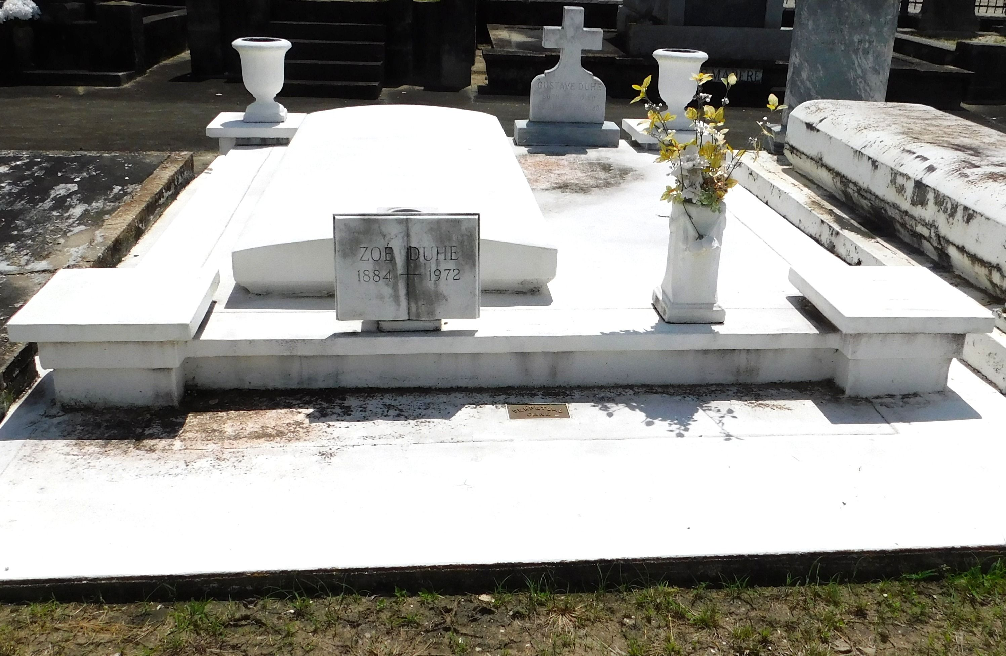

Photo by Mary Agnes Hammett

Zoe Duhe, Age 87 years, a native and resident of Reserve, Louisiana.

Wife of the late Gustave Duhe, mother of Joe Duhe of Reserve, Mrs. Guy Cambre of Laplace, Louisiana, Mrs. S R Smith of Bush, Louisiana, and the late Leon Duhe. Sister of Ambroise Duhe of Reserve.

Services were Monday 7 Feb 1972 at St Peter Church, Reserve, with interment in St Peter Cemetery.

Times Picayune, New Orleans, Louisiana

February 6, 1972