Nicholas "Nick" Michael Duhe

May 22, 1997 - July 5, 2024

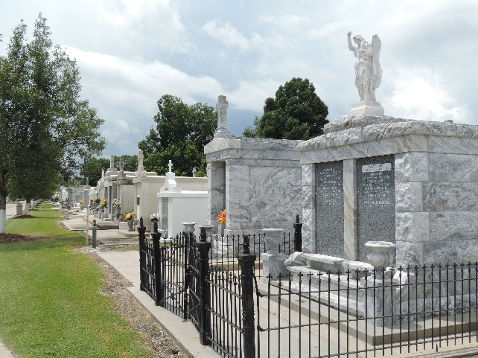

Nicholas “Nick” Michael Duhe passed away unexpectedly on July 5, 2024 at the age of 27. He was born in Houma, Louisiana, and a native of Garyville, Louisiana.  
 Loving son of Damon Michael Duhe and Tammy LeBouef Roussel. Brother of Alexis Lewis (Taylor), and Uncle to Levi Lewis. Grandson of Faye Duhe and the late Elmer Duhe, Mary Gueret Miller (Scopey) and the late Darol LeBouef. Nephew to Johnathan Jacob, Summer LeBouef Stevenson (Shawn), Brian Duhe, Shaun Duhe (Crystal), and Ashley Duhe. He was also survived by numerous aunts, uncles, and cousins.  
 Nick was engaged to be married to Nicole Knight and he loved her three girls Serenity, Cataleya, and Christina as his own.  
 He enjoyed being outdoors; fishing and duck hunting. He was very outgoing and enjoyed spending time with his family and friends. He loved to make people laugh. His smile would light up the room when he walked in.  
 Nick was a proud superintendent for Danios out of Grey, Louisiana.  
 Relatives and friends are invited to attend the Visitation and Funeral Mass at Millet-Guidry Funeral Home, 2806 West Airline Highway Laplace, Louisiana on Saturday, July 13, 2024. Visitation will be held from 9:00 a.m. - 11:00 a.m. followed by a Funeral Mass at 11:00 a.m. Entombment in St Peter’s Cemetery, Reserve, Louisiana.  
 The family would like to thank Millet- Guidry funeral home for their prayers and compassionate care of Nicholas.

Millet-Guidry Funeral Home, LaPlace, Louisiana

July 11, 2024