Charles Michael Duhe

November 30, 1947 – January 20, 2017

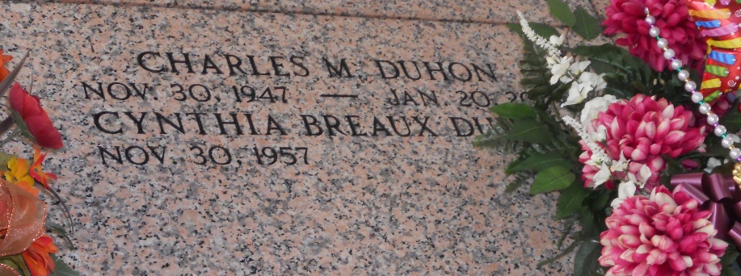

Photo by Team T-Lo

Charles Michael Duhon, lifelong resident of St. John the Baptist Parish, passed away peacefully surrounded by loving family on Friday, January 20, 2017 at the age of 69.

He was the beloved husband of Cindy Breaux Duhon of 26 years. Loving father of Dawn White (Timmy), Trisha Duhon, Jaime Aucoin (Danny), Stephanie Miles, and Shanna Rauch (Jason), Michelle Duhon and Rachael Shier. Doting grandfather of Timmy Jr. and Corryn White, Frank Volion, Jr., Emily, Dani and Drew Aucoin, Julian Miles, Bailey and Aubrey Rauch. Also grandfather to Kayla, Kayce, Kandace, Paul and Alexis.

Survived by his mother Inez Duhon Blank, brothers Alvin Jr. (Cheryl), George (Shirley), Eric (Sheryl), Brent (Kathy), Kevin (Kathy), Saul, Aaron (Renee) Duhon; sisters Linda (Martin) Mustacchia, Cindy (Kevin) Maddie, and Wendy Duhon. Preceded in death by his father Alvin Duhon, Sr. and brother Arthur Duhon.

Charles was a retired employee of Shell Motiva of 38 years where he was a Health and Safety Manager of Field Operations. He was recognized for his numerous contributions to the improvement of the Corporate Emergency Management Systems, as well as the Occupational Health and Safety Programs. He was the founder of the youth organization LEBRO, where he coached many of the parish's youth boy's football and girl's cabbageball. He was passionate about politics and a good debater, but his greatest joy was being with his wife, daughters and grandchildren. Charles also loved his reign as King duMonde XXXI. He will be greatly missed by all who knew and loved him.

Relatives and friends are invited to attend the Funeral Mass at St. Peter Catholic Church, 1550 Hwy. 44. Reserve on Monday, January 23, 2017 at 11:00 a.m. Visitation at the church from 9:00 a.m. to 11:00 a.m. Interment in St. Peter Cemetery. In lieu of flowers, please make donations to St. Peter Catholic Church in Reserve, LA. Arrangements by Millet-Guidry Funeral Home.

TheNewOrleansAdvocate.com

Jan. 21 to Jan. 23, 2017