Kathy (Rizzuto) Duhon
January 11, 1957 – June 12, 2024

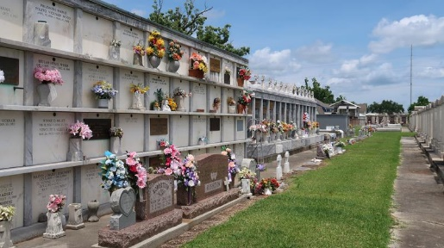

We of weighted heart bid farewell and voice our final wish for a journey onward filled with peace, joy, and radiance to Kathy Rizzuto Duhon. On Wednesday, June 12, 2024, at the age of 67, the earthly leg of her journey marked by grace, courage, and resilience came to a untimely and heartbreaking end.
Kathy was born in Lutcher, LA and a resident of Reserve, LA. She is remembered as: Beloved wife of Kevin James Duhon, Sr. Loving mother of Kevin J. Duhon, Jr., Katie Duhon Beadle (Bryan) and Kaleb Duhon. Grandmother of Demi Duhon (Tiffany Brown), Haley Beadle, Laney Beadle, Kacey Beadle and Molly Beadle. Great grandmother of Grace Geddie. Daughter of Freida LeBlanc Rizzuto and Roy Anthony Rizzuto. Sister of Tommy Rizzuto, Sr. (Maude) and Susan Rizzuto Duhe (Dana). Also survived by cherished Godmother Frances (Bird) LeBlanc, Godchildren Jared Rizzuto, Melanie Zeringue Riff, Chelsea Duhe, and Ashley Trosclair Teague, as well as many nieces, nephews, and cousins.
Relatives and friends are invited to attend the Visitation and Memorial Mass at St. Peter Catholic Church, 1550 Hwy 44, Reserve on Thursday, June 20, 2024 from 9:00 a.m. to 11:00 a.m. followed by a Memorial Mass at 11:00 a.m. Inurnment in St. Peter Cemetery.
Millet-Guidry Funeral Home, LaPlace, Louisiana

