Viola (Louque) Duhon
July 20, 1905 – October 26, 1999

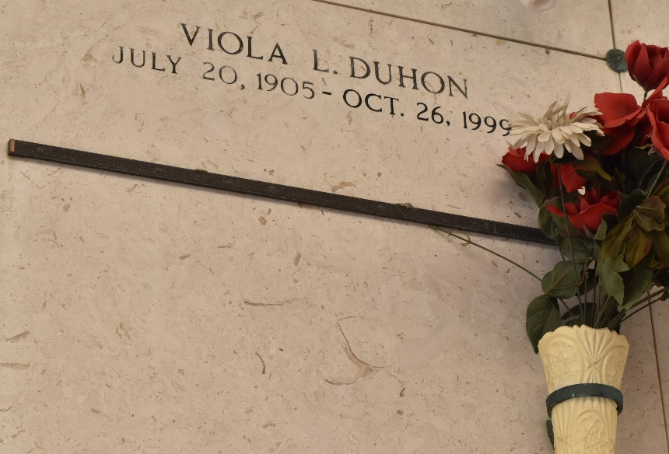

LAPLACE - Viola Louque Duhon, 94, a native of Grand Point and a resident of Reserve for 75 years, died Oct. 26.
She was the wife of the late Eddie Duhon and mother of Audrey Cambre, Mary Michel, Violet Berthelot, Alice Zeringue, Glenda Vedros and Ned and Eddie Duhon Jr. She was also the daughter of the late Adrian and Adorestine Louque and sister of the late Leticia St. Pierre, Amelia Bergeron, Augustine Roussel, Nellie Jacob and Leon, Ezidore, Alice, Clarence, Steve, Irby and Regina Louque. She is also survived by 36 grandchildren, 72 great-grandchildren and nine great-great-grandchildren.
Services were held Oct. 29 at St. Peter Catholic Church, Reserve, with interment at the church cemetery.
L'Observateur, LaPlace, Louisiana
October 30, 1999

