Annabelle (Gibson) Dunn
December 23, 1932 – May 28, 2011

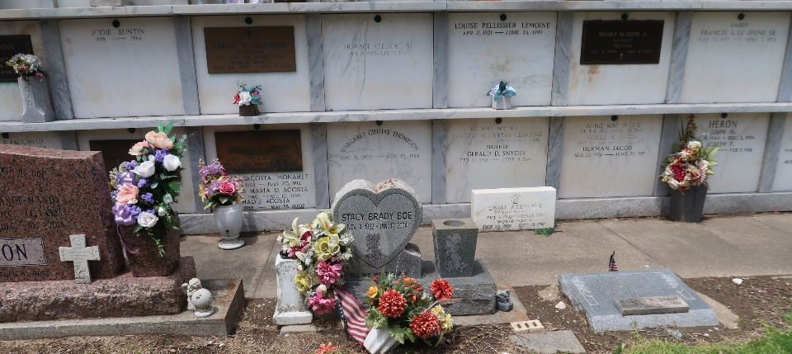

Annabelle Gibson Dunn died on Saturday, May 28, 2011 at St. Theresa Specialty Hospital in Metairie, LA. She was 78 years old.
She was the daughter of the late Emelda Riley Edwards and Clement Gibson Sr. and stepfather James Edwards Sr. She was sister of the late Clement Gibson Jr. (wife Gwendolyn), James Edwards Jr. (wife Pauline) and Annie Mae Edwards. She was the former wife of the late Ernest Dunn Sr. She is survived by a daughter, Leah M. Dunn of LaPlace, 3 sons, Ernest Dunn Jr. (wife Gail) of LaPlace, David Dunn Sr. (wife Sylvia) of Reserve, and Reginald Dunn Sr. (wife Jacqueline) of Compton, CA, 2 half-brothers, Clement Gibson III and Michael Gibson of New Orleans and a devoted friend, Geraldine Brown of St. Rose. She was a native of Reserve and a graduate of Fifth Ward High School.
A funeral will be held Friday, June 3, 2011 at 11:00 a.m. at First Community Antioch Baptist Church in Lutcher, LA, 10860 Hwy. 3125, Lutcher, La. Pastor Ferdinand Gaines, Jr., officiating. Visitation Thursday, June 2, 2011 at The Baloney Funeral Home LLC, 399 Earl Baloney St., Garyville, La., 985-535-2540, from 2:00 p.m. until 6:00 p.m. Church visitation on Friday, June 3, 2011 will begin at 9:00 a.m. until time of service. Burial at St. Peter Catholic Church, Reserve, La. Baloney Funeral Home in charge of arrangements.

The Times-Picayune, New Orleans, Louisiana
Jun. 2, 2011

