Lenda (Wilson) Dunn
February 27, 1933 – January 16, 2023

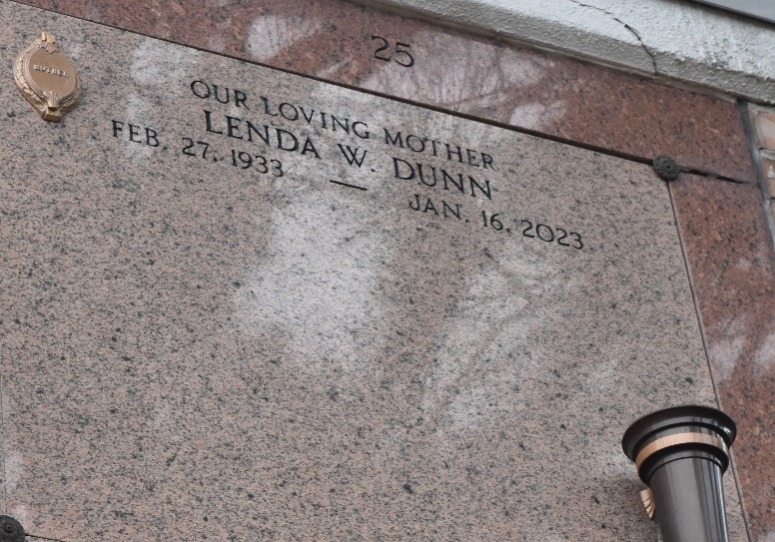

Lenda "CoCo" Wilson Dunn, a faithful and loyal servant of God, found rest in the arms of her eternal Father's on Monday, January 16, 2023. A native and resident of LaPlace, Louisiana,
Lenda was born to the parentage of the late John and Mathilda White Wilson on February 27, 1933. She was baptized in catholic faith and attended Our Lady of Grace Roman Catholic Church where she served faithfully. "CoCo," as she was affectionally known, was a devoted member of St. Catherine Ladies Auxiliary, Court #73.
Lenda was united in holy matrimony to the late Willie Dunn. To this union, two beautiful children were born; Valencia Dunn and Gralyn Dunn; and she embraced her stepdaughter, Beverly (Carey) Gauff, Sr.
CoCo attended school in St. John the Baptist Parish, and graduated with the class of 1951, at Fifth Ward High School. She pursued higher education at Southern University where she received her Bachelor's degree in Elementary Education, and Nichols State University where she received her Master's degree. Education was essential to Lenda, and she returned to Southern University and obtained 30 plus hours above her Master's degree.
She was employed in St. John the Baptist Parish School System as a teacher for more than 33 years where she taught and imparted the value of learning to many students across the parish. Lenda had a passion for cooking, spending time with family and friends, cheering on the Saints during football season and going to the casino. She enjoyed going to and working within the church and St. Catherine Ladies Auxiliary, Court #73. CoCo's favorite song was, "I won't complain." She would always say, "God sits high, but looks low." Proverbs 10:7 says the memory of the Just is Blessed!
Lenda leaves to cherish her memories; Valencia Dunn, Gralyn (Daphne) Dunn and Beverly (Carey) Gauff, Sr.; grandchildren, Credere and Jamie Joseph of Northridge, California, Kristen, Kirsten and Trenton Dunn; great-grandchildren, Asia Farlough, LaVoy Gerard, Jr., Jansen Joseph, Rylee' Dunn, and Jaci Joseph; a sister, Jacqueline (Roland Sr.) Jackson and a brother-in-law, Edward Moton both of Los Angeles, California; two Godchildren, Sylvia Stevenson and Debra McQuarn, and a host of nieces, nephews, other relative and friends.
Lenda, was proceeded in death by her parents, John and Mathilda White Wilson; former husband, Willie Dunn; siblings, James (Bessie) Wilson, Sr., Harold (Alberta) Wilson, Clarence (Edna) Wilson, Rubin (Emelda) Wilson, Cecile (Will) Hall, Margaret (Clifford) Lawrence, Catherine Moton, and Beatrice (Napoleon) Ben.
A celebration of life honoring Lenda "CoCo" Dunn will be held on Monday, January 23, 2023 at 10am at Our Lady of Grace Catholic Church, 780 LA-44, Reserve, LA 70084. Visitation will be held from 8:15am-10am. Recitation of the Holy Rosary will begin at 8:45am. Father Etido Jerome, SSJ, Celebrant. Entombment to follow at St. Peter Catholic Church Cemetery, 1550 LA-44, Reserve, LA 70084.

Treasures of Life Funeral Services, Gramercy, Louisiana

