Sidney Antoine Dupuy

November 6, 1861 – December 10, 1936

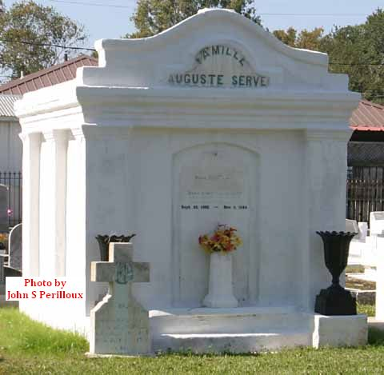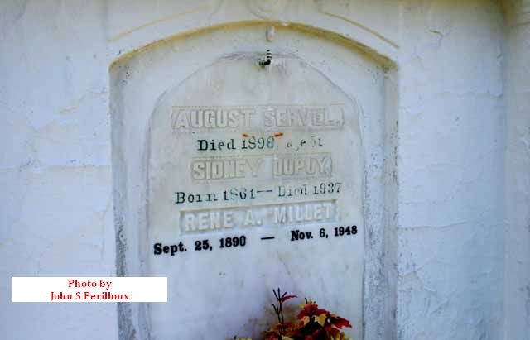

Photos by John S. Perilloux; contributed by Dwayne Montz

Sidney A Dupuy died on Thursday 10 Dec 1936 at 7:20 o'clock p.m.

He was the husband of Ursule Millet and the father of Mrs. Ernest Hugo, Mrs. L J Savana, and Mrs. Fred Goelzenleuchter. Age 75 years, a native of Reserve, Louisiana.

Relatives and friends of the family are invited to attend the funeral which will take place from the parlors of Leitz-Daigre, 2241 Magazine street. Remains will be taken by automobile Saturday morning 12 Dec 1936 to Reserve, Louisiana, for interment.

The Times-Picayune, New Orleans, Louisiana

11 Dec 1936