Julia Annabelle (Lambert) Dwyer
January 30, 1910 – July 29, 2001

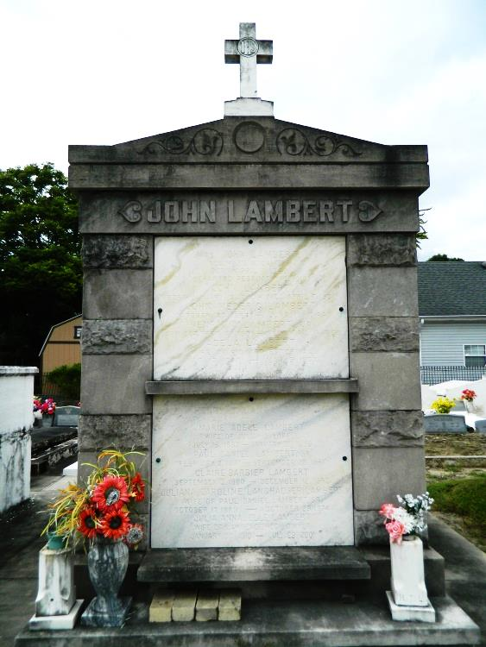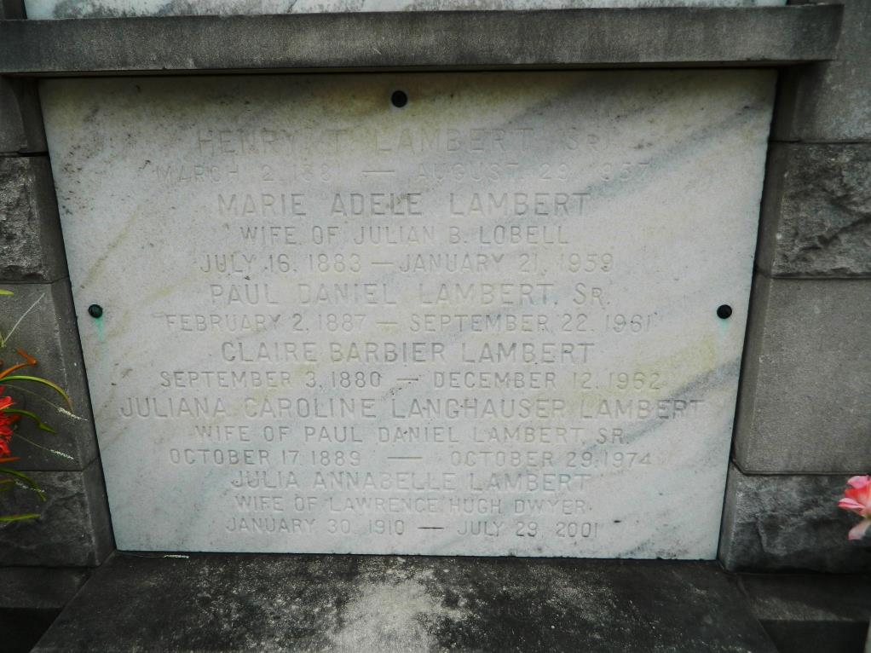

Julia AnnaBelle Lambert Dwyer on Sunday, July 29, 2001 at 8:50 p.m. Beloved wife of the late Lawrence Hugh Dwyer. Mother of Edward K. Dwyer, Anne D. Walle, Edith D. L'Hoste and the late Lawrence H. Dwyer, Jr. Daughter of the late Juliana Langhauser and Paul Daniel Lambert. Sister of Helen L. Ross, Edwina L. Casey, J. James, Henry Roland and Warren Charles Lambert and the late Ethel L. Damare, Paul Daniel, J. Harold and Edward W. Lambert. Also survived by 13 grandchildren and 2 great grandchildren.
Age 91 years, a native of Kenner and a lifelong resident of the New Orleans area.
Relatives and friends of the family are invited to attend a Memorial Mass at Mater Dolorosa Catholic Church, 1230 S. Carrollton Avenue, New Orleans, LA 70118 on Thursday, August 2, 2001 at 11:00 a.m. Interment in St. Peter Cemetery, 143 West 7th. Street., Reserve, LA. Visitation at the church from 10:00 a.m. until time of service. In lieu of flowers, donations to The Roquette Lodge Garden Fund, 4300 Highway 22, Mandeville, LA 70471 preferred. Arrangements by L.A. MUHLEISEN AND SON.
Times-Picayune, The (New Orleans, LA) - Wednesday, August 1, 2001
Contributed by Jane Edson

